PhD candidate: XXXX
Date: XX/XX/20XX
Time to PhD submissions (in months): XX months

🧠 Research Progress
Generating knowledge about PhD topic | Color code for visual guidance
- The candidate has been doing some reading

Clarity of research objectives
Progress toward milestones
- Experimental work has only recently started

Experimental design
Data collection and analysis
- NA

🛠️ Skills Development
Research skills (e.g., lab techniques, coding, reactors)
- Actively trying to learn hands-on skills
Critical thinking
- Good mind-set, asking questions

Problem-solving
- Looked for advise when issues arose

Proactivity
Project management
- Focus is needed in making experiments and progress happen
Other (soft) skills
- Candidate has followed training on …

🤝 Supervision and Collaboration
Engagement with promotor team
Responsiveness to feedback
- Feedback is considered
Communication style
- Interactive and fluent

Collaboration with CMET colleagues or externals
Proper planning and preparation of meetings
- A bit more structure is needed in the meetings

📚 Expected outcomes for next feedback moment
Experimental progress
PhD manuscript writing progression
- xx pages of literature review (to be sent a few weeks before 1 year feedback)
- First structure of the thesis with 4 research chapters
Participation in trainings & events
- Candidate is actively looking for interesting trainings & events
Scientific output (e.g. manuscripts, abstracts to conferences, etc.)

Guidance:
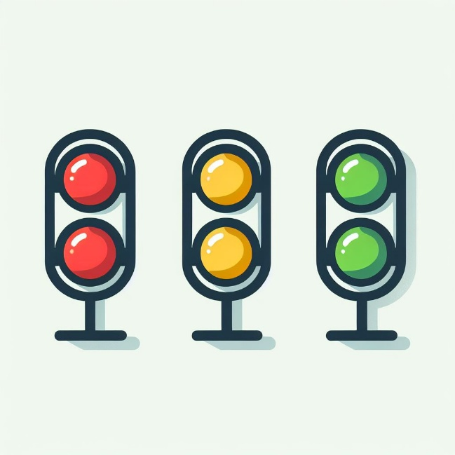 | Progress according to expectations. Keep on the good work
 | There is sufficient progress, but with some attention points
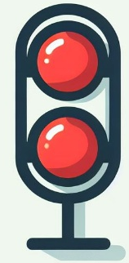 | Progress is not adequate. Improvement is needed

