U-HPLC-HRMS data analysis manual
Thermo-Scientific Benchtop Exactive Orbitrap

Table of contents

1. Files 3
2. First thing to do: backup 3
3. Xcalibur software 3
4. Sequence Setup – Sequence List 4
5. Working with Qual Browser 8
6. Creating a Processing Setup 17
7. Completing the Sequence List 21
8. Working with Quan 24
9. Exporting to Microsoft Excel 26

This document is accompanied with a set of theoretical mass isotope distributions of the ionized precursors of the OMPs, either a printed set (available in my office) or a digital set (ask me to mail them).

Files
After analysis of the samples, you will get the following files, which are needed to process your data
- A set of .raw files: contains all the measurement information of the injections of the run. One .raw file equals one injection.
- An .sld file: sequence list file, contains a list of all the injections of the run.
- A .pmd file: this is an example of a processing setup.
- A .lyt file: this is an example of a layout, used in Qual Browser.
Hint: in Windows, you can choose to display the extensions (.raw, .sld, …) by clicking Start – Control Panel – Folder Options – View tab, and unchecking Hide extensions for known file types.

First thing to do: backup
Before processing or opening any of the files, make a backup of the .sld file.

Xcalibur software
Open the Xcalibur software. The window you get upon opening the software is called the Xcalibur Roadmap (Figure 3.1). This is the main window, used to navigate in between different parts of the Xcalibur software.
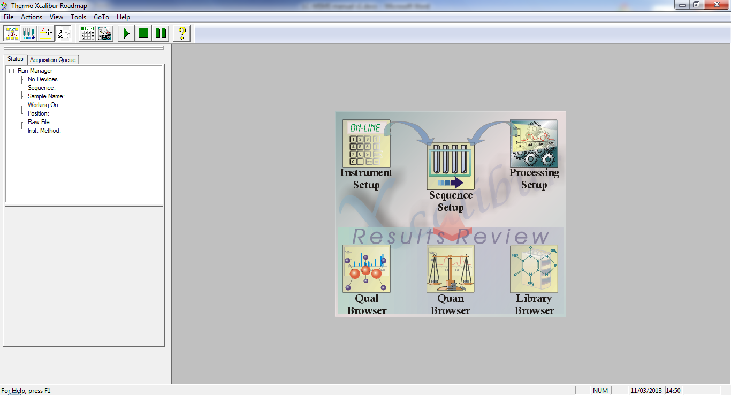
Figure 3.1: Xcalibur Roadmap

Sequence Setup – Sequence List
In the Xcalibur Roadmap, click the Sequence Setup button. Load the Sequence List (.sld file) you have received (File – Open). A list of all the injections that have been done into the LC-MS system opens up. Each line represents one injection. At this point, the following columns are of importance:
- File Name: the name of the corresponding .raw file
- SampleName: the name of the injection
- Path: the path where the .raw files should be located
- Inst Meth: the analysis method which has been used. There are two methods:
  - Pesticides method (…\Pesticiden140106_FinalLong-100-700)
  - PF method (…\130214PFs_final)
In general, only the Pesticides method will be performed, since the PF method is very time consuming and analysis time is not always at hand.
Using the Pesticides method, the compounds presented in Table 4.1 can be analyzed.
Table 4.1: Analytes measured with Pesticides method
Compound | Ionisation (+/- ESI) | m/z range | Mass precursor ion dominant isotope
atrazine | + | 100-700 | 216.10105
chloridazon | + | 100-700 | 222.04287
dimethoate | + | 100-700 | 230.00690
diuron | + | 100-700 | 233.02429
pirimicarb | + | 100-700 | 239.15025
simazine | + | 100-700 | 202.08540
triclopyr | - | 100-700 | 253.91840
diglyme | + | 100-700 | 135.10157
caffeine | + | 100-700 | 195.08765
carbamazepine | + | 100-700 | 237.10224
clofibric acid | - | 100-700 | 213.03240
diatrizoic acid | + | 100-700 | 631.80346
diclofenac | + | 100-700 | 296.02396
gemfibrozil | - | 100-700 | 249.14962
hydrochlorothiazide | - | 100-700 | 295.95720
ibuprofen | - | 100-700 | 205.12340
ketoprofen | + | 100-700 | 255.10157
lincomycin | + | 100-700 | 407.22103
metoprolol | + | 100-700 | 268.19072
naproxen | + | 100-700 | 231.10157
paracetamol | + | 100-700 | 152.07061
phenazone | + | 100-700 | 189.10224
ranitidine | + | 100-700 | 315.14854
salicylic acid | - | 100-700 | 137.02343
sulfamethoxazole | + | 100-700 | 254.05939
terbutalin | + | 100-700 | 226.14377
theophylline | + | 100-700 | 181.07200

Using the PF method, the compounds presented in Table 4.2 can be analyzed.
Table 4.2: Analytes measured with PF method
Compound | Ionisation (+/- ESI) | m/z range | Mass precursor ion dominant isotope
PFOA | - | 120-1000 | 412.96838
PFOS | - | 120-1000 | 498.93225
gemfibrozil | - | 120-1000 | 249.14962
ibuprofen | - | 120-1000 | 205.12340
metformin | + | 50-1000 | 130.10872
naproxen | - | 120-1000 | 229.08702
salicylic acid | - | 50-1000 | 137.02442

Note: metformin exerts heavy tailing, but usually it can still be processed, while salicylic acid usually cannot be processed with the PF method due to heavy retention time differences. Naproxen, salicylic acid (with a slightly different mass), gemfibrozil and ibuprofen can be processed with both methods, albeit with a lower sensitivity for the Pesticides method. Salicylic acid is often better processed with the pesticides method due to less retention time differences.

Since the data is analyzed on another computer than the one where the measurements take place, some paths will be different. The only one of importance for data processing is the path where the .raw files are located, so this one will need to be changed. To do this, right-click on the ‘C:\Xcalibur\Data’ cell of the first injection, and browse towards the folder where the .raw files of your measurement run are located. Click OK to confirm the path. Now click on the Path header to select the whole column (Figure 4.1).
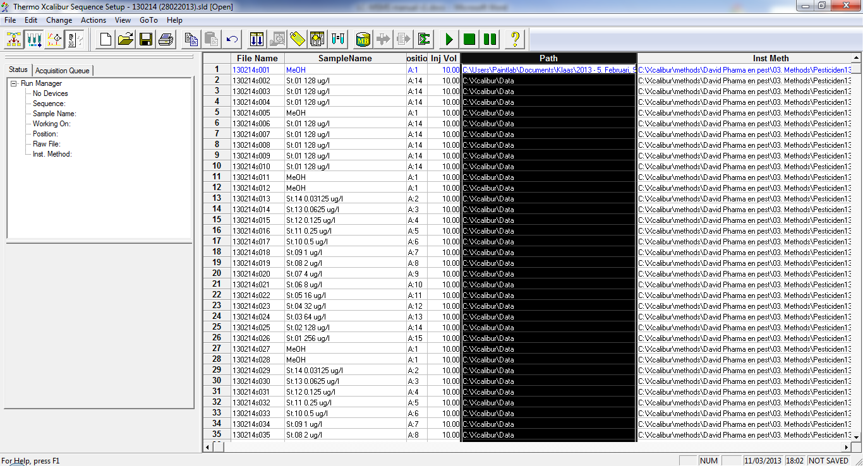
Figure 4.1: Sequence List - Changing Path
Press the Fill Down button (Figure 4.2), and fill the Path column from row 2 until the end using row 1 (Figure 4.3).
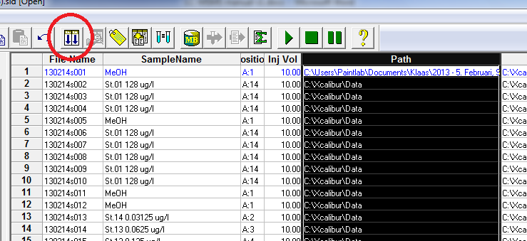
Figure 4.2: Sequence list - Fill down button
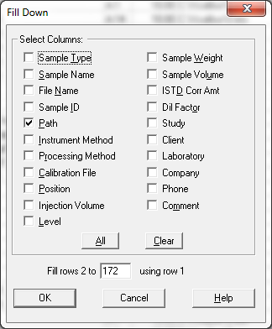
Figure 4.3: Sequence List - Fill down menu
Save this sequence file (you can overwrite the old one).
Now you will have to clean up the sequence file. There are a number of injections which you don’t need: MeOH injections, a little sequence of injections of the same standard in the beginning, at the end a MeOH injection with a SPOEL (rinse) method, samples of someone else, …. Delete these injections. In case both methods have been run, delete all the injections of the second method as well.
Normally you should end up with your calibration series, followed by your samples. Save this sequence as a new file (e.g. 130214 – Pesticides method). When prompted a File Summary Information window, just press OK, or fill in some comments in the box before pressing OK. You can do the same for the PF method injections, if applicable (save this one as e.g. 130214 – PF method).
You can return to the Xcalibur Roadmap by pressing the Roadmap View button (Figure 4.4).
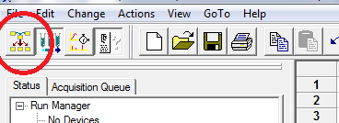
Figure 4.4: Sequence List - Roadmap View button

Working with Qual Browser
Working with the Qual Browser is in principle not necessary for data processing, however going through this chapter will help you understand better how the Xcalibur software works.
In the Xcalibur Roadmap, press the Qual Browser button. The Qual Browser opens in a new window.
You can use the Qual Browser to open a .raw file, display chromatograms and m/z spectra, subtract background data, create and save layouts, apply filters, … In the case demonstrated below, we will use it to display a set of analytes, measured with the Pesticides method.
First, open the cleaned up sequence list (File – Open Sequence). On the left, a list of .raw files present in the Sequence List appears. Go back to the Sequence Setup window (in the Windows task bar, press Thermo Xcalibur Roadmap – Sequence Setup) to see more details from this list. Look up the name of a high standard (e.g. 250 µg/L), and remember the name of the file (e.g. …s042). Go back to the Qual window (in the Windows task bar, press Thermo Xcalibur Qual Browser), and double-click this …s042.raw file.
A screen with on top a chromatogram, and at the bottom an m/z spectrum appears. The way of how this is displayed is determined by the layout. This standard layout is not usable for our purposes, so it is necessary to change/make a new layout. It is best to load the example layout included in the files you have received. Apply this layout (File – Layout – Apply). Now the layout is changed to on the left side a series of chromatogram plots, and on the right side an m/z spectrum (Figure 5.1).
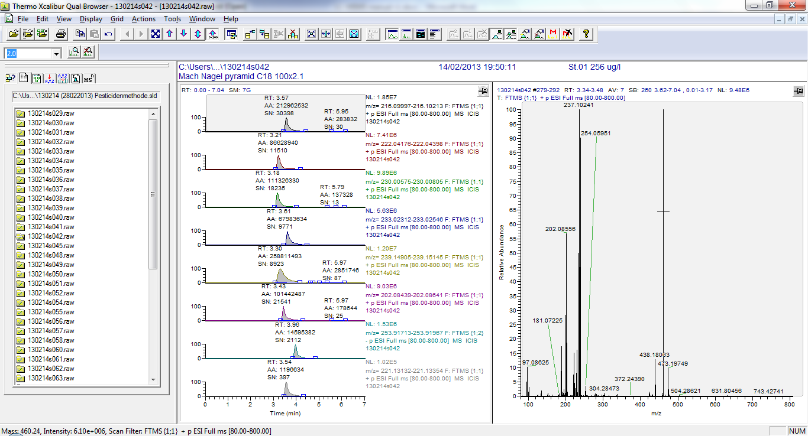
Figure 5.1: Qual Browser - Layout example of a 256 µg/L standard
In the left part of the layout, there are a maximum of 8 chromatogram plots. A layout contains a maximum of 8 masses (each one corresponding to one of the chromatogram plots), and a number of settings. The software will search for these masses in the .raw file, and display a peak where the mass was detected. Thus, in order to look up the chromatogram plot of an analyt of interest, you need to enter its mass in the Chromatogram Ranges box. This can be accessed by right-clicking on the pin of the chromatogram plots section and subsequently by choosing Ranges (Figure 5.2).
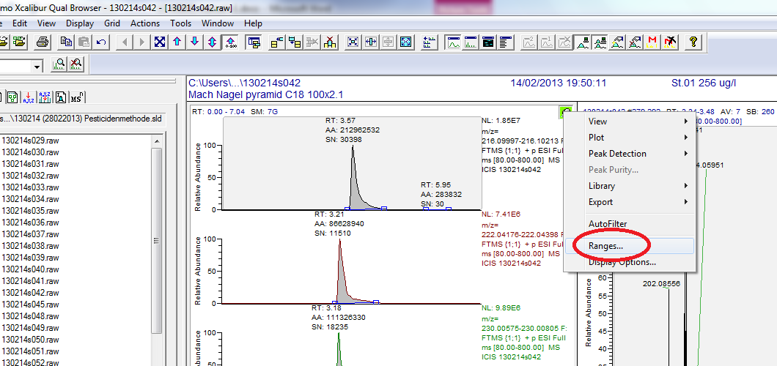
Figure 5.2: Qual Browser - Accessing Chromatogram Ranges

The Chromatogram Ranges box appears (Figure 5.3).
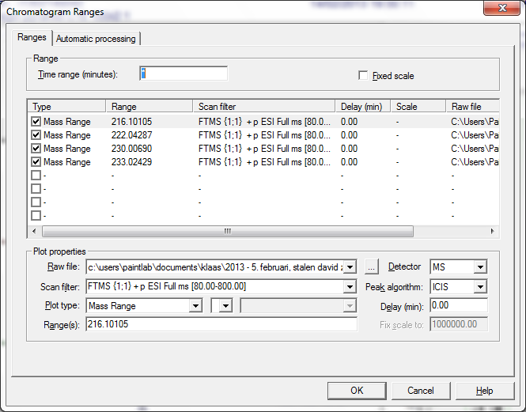
Figure 5.3: Qual Browser - Chromatogram Ranges menu
In the Ranges tab, there are a maximum of 8 lines, where you can enter the masses of the ionized precursor ions of the OMPs. In the above example, the 4 entered masses correspond to the following 4 pesticides: atrazine, chloridazon, dimethoate and diuron.
Add the other pesticides, and the internal standard (atrazine-d5) to this layout by clicking one of the free lines and filling in the mass at the bottom (Figure 5.4).
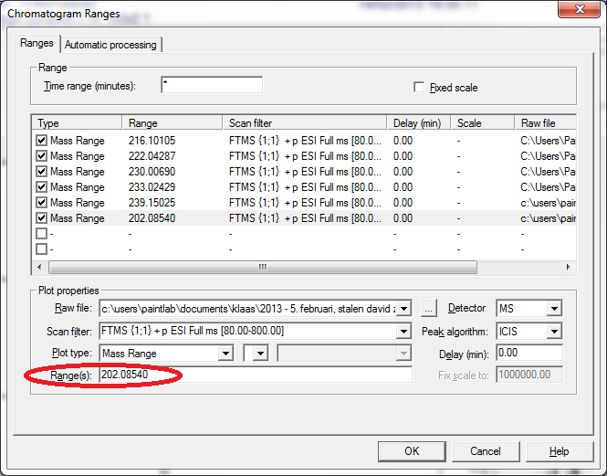
Figure 5.4: Qual Browser - Chromatogram Ranges pesticides example
Make sure to select, for Scan filter, the right ionisation mode (+p ESI for the positive precursor ions,
-p ESI for the negative precursor ions) and mass range (Full ms [100.00-700.00] for the Pesticide method, either Full ms [50.00-1000.00] or [120.00-1000.00] for the PF method). A list of the masses of the precursor ions, along with their corresponding ionisation modes (+p ESI or -p ESI) of the OMPs is given in Table 4.1.
In Figure 5.5 the Chromatogram Ranges window for the 7 pesticides and the atrazine-d5 internal standard is given. Notice that only triclopyr has a negative precursor ion, and is thus the only one with the negative Scan filter.
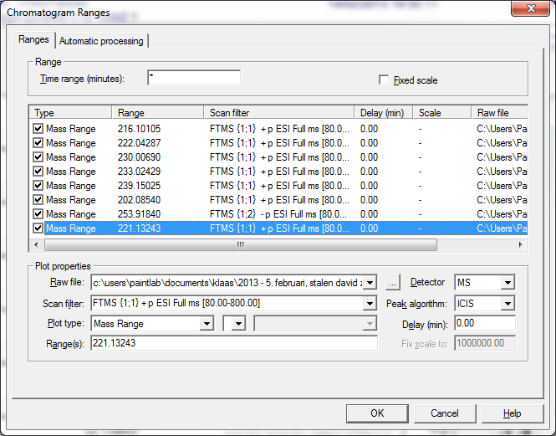
Figure 5.5: Qual Browser - Chromatogram Ranges pesticides completed example
In the Automatic processing tab, put the settings as indicated in Figure 5.6.
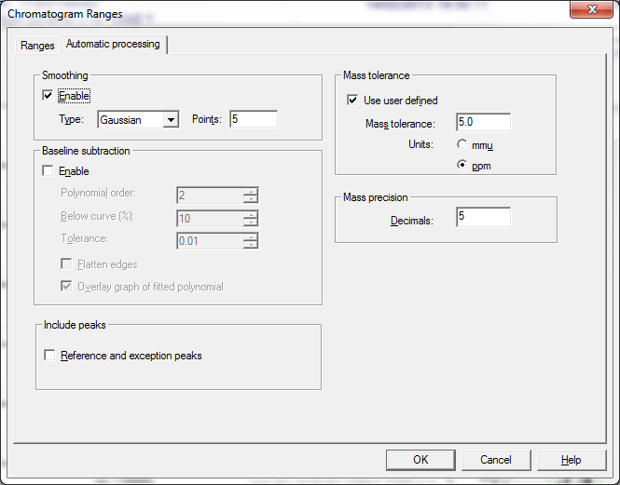
Figure 5.6: Qual Browser - Chromatogram Ranges, Automatic processing settings
Very important is to have the Mass tolerance not higher than 5.0 ppm. The mass precision should be on 5 decimals.
Click OK to adjust the left part of the Qual Browser (the chromatograms) to these masses and settings.
You can save this layout for future purpose (File – Layout – Save as). Hint: include the method name and precursor ion names in the file name (e.g. Pesticides method atra+ chlo+ dime+ diur+ piri+ sima+ tric- atra-d5+.lyt).
Now we can get some more info about the 8 pesticides displayed in the left part of the Qual Browser.
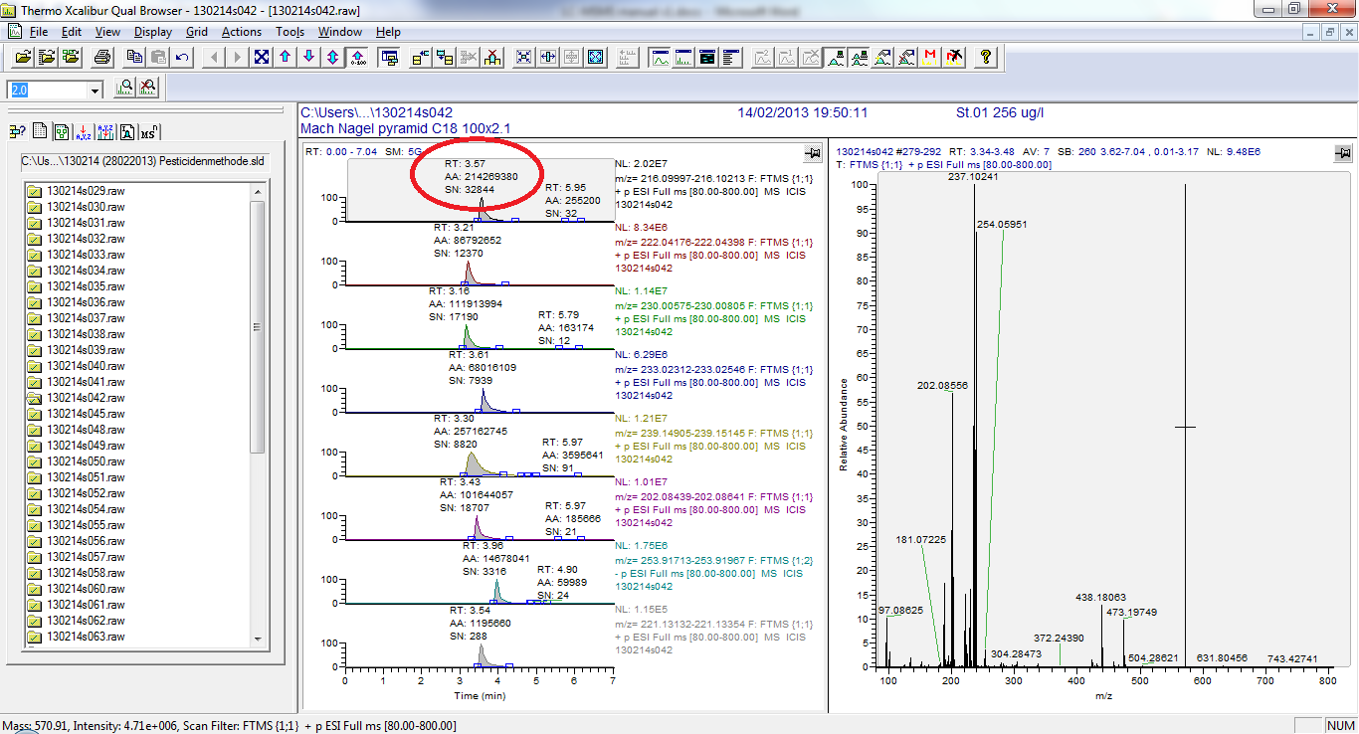
Figure 5.7: Qual Browser - Peak information
In the circle in Figure 5.7, the following information is displayed:
- RT: retention time of the top of the peak (minutes)
- AA: Area of the peak (arbitrary units)
- SN: Signal to noise ratio (arbitrary units)
In case a peak is not automatically integrated (this can possibly be the case for low concentrations), you can press the Add Peaks button, and select the peak manually (Figure 5.8).
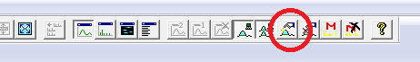
Figure 5.8: Qual Browser - Add peak manually button
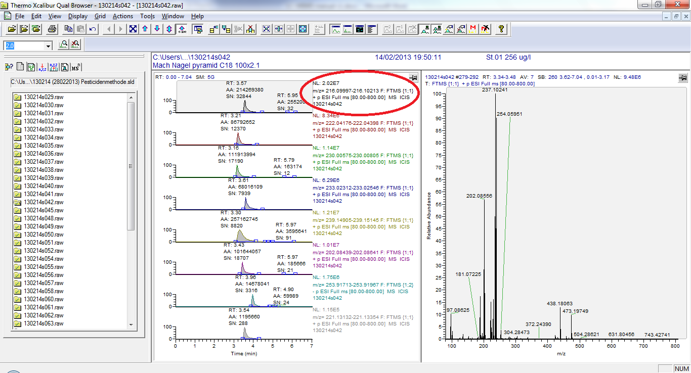
Figure 5.9: Qual Browser - Chromatogram information
In the circle in Figure 5.9, the following information is displayed:
- NL: another measure for signal strength
- m/z: a range of the mass ± 5 ppm
- the scan filter
- the .raw file name
You can zoom in on a chromatogram plot by clicking on the chromatogram plot and dragging a horizontal line over the part of the chromatogram you want to zoom in on. Zooming out can be done by pressing the Zoom Reset button (Figure 5.10).
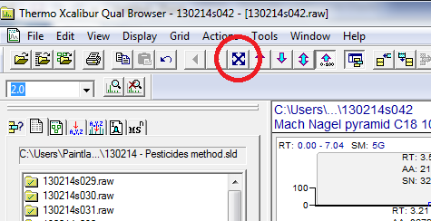
Figure 5.10: Qual Browser - Zoom Reset button

In the right half of the layout, an m/z spectrum is displayed. This spectrum displays a sum of all the m/z lines detected in the injection. In order to look up the m/z lines corresponding to a peak in the chromatogram plot, first activate the m/z spectrum by clicking on the pin in the top right corner of the m/z spectrum part of the layout (the plot of interest will now have a light blue background). Then click once on the chromatogram plot of interest (the one corresponding to the mass of the analyt of interest, in the left part of the layout). Finally, we will subtract the background m/z lines by clicking the Subtract 2 Ranges button (Figure 5.11).
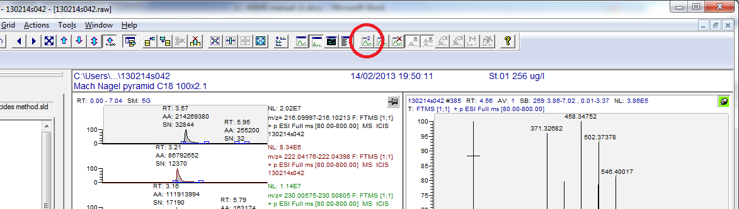
Figure 5.11: Qual Browser - Subtract 2 Ranges button
After clicking the button, a -1 appears next to the mouse pointer. Hover your mouse pointer right next to the left side of the peak (so a few pixels to the left of the left side of the peak), approximately at half the height of the peak. Click and drag the mouse pointer horizontally all the way to the t = 0 minutes point, then release the mouse button. Now a -2 appears next to the mouse pointer. Hover towards the right side of the peak, click at half of the peak height right next to the peak (so a few pixels to the right of the peak), and drag horizontally all the way to the end of the measuring time. After releasing the mouse button, the software will recalculate the m/z spectrum by removing the noise from the 2 subtracted ranges, however, you will still need to select the peak of interest by clicking on the left border of the peak at half peak height, dragging to the right border of the peak and releasing the mouse button.
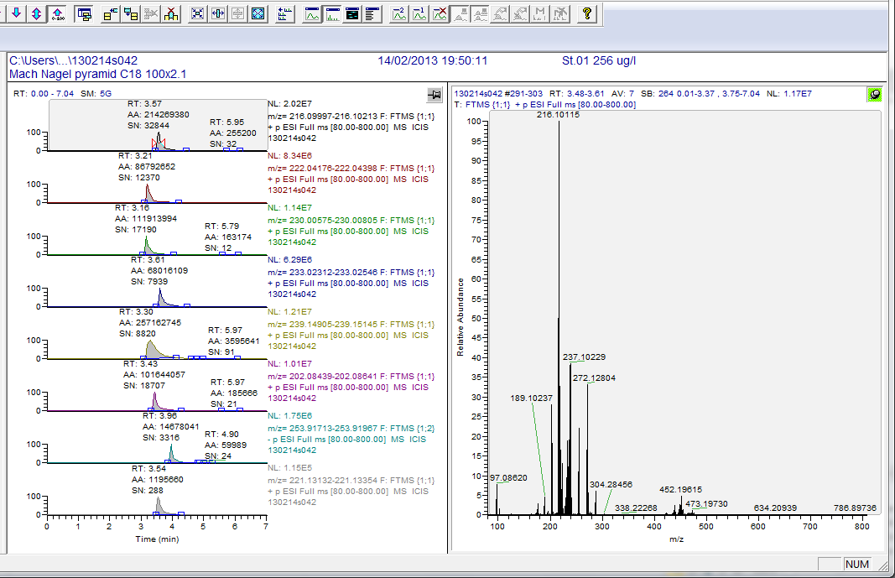
Figure 5.12: Qual Browser - Selected peak and adjusted m/z spectrum
The selected part of the peak is now displayed in between red triangles, and the m/z spectrum should be displaying the m/z line of the analyt of interest (Figure 5.12).
In order to be sure that the peak is indeed the analyt of interest, two criteria need to be fulfilled: the RT needs to be more or less the same as the RT in a high standard, and the m/z line spectrum must display a correct m/z distribution as with the theoretical m/z distribution. These theoretical m/z distributions are available in printed version in my office. If you need them digitally, please contact me.
Take the theoretical m/z spectrum of the analyt of interest, and compare it with the m/z spectrum in the Qual Browser. You can zoom in by dragging horizontal lines across the spectrum. In the theoretical m/z spectrum, there is a dominant line (the left one), representing the analyt composed of the most abundant isotopes. The line to the right (with 1 m/z higher) of the dominant line is the analyt containing one ¹³C isotope. The relative height of this line should be more or less the same as the one in the Qual Browser. If this isotope distribution corresponds to the theoretical one, then you can be sure that the peak is indeed the analyt you are looking for. If the measured m/z spectrum of the detected peak is not corresponding to the theoretical m/z distribution, then the detected peak is not the analyt of interest and the analyt should be marked as not detected.
Luckily, you don’t have to process all analytes in all samples this way, we can use the Processing Setup for this!

Creating a Processing Setup
In the Xcalibur Roadmap, click on Processing Setup. Open the example Processing Setup file (File – Open) (Figure 6.1).
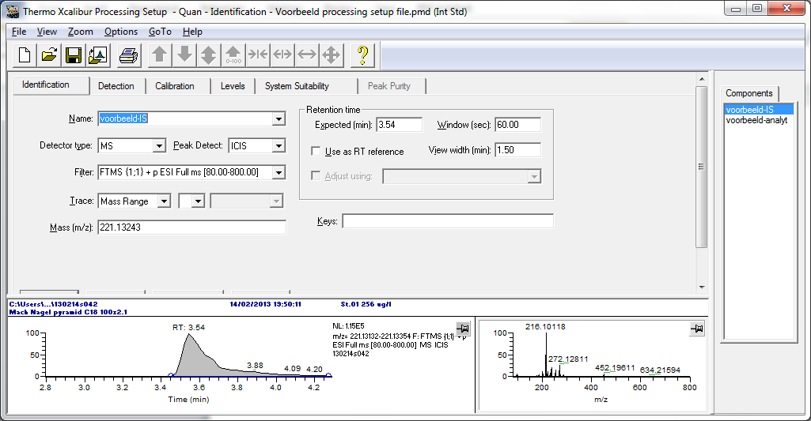
Figure 6.1: Processing Setup - Example
Using this piece of software, we can create a processing setup file that we later can use to transform the analysis data of our samples and calibration curve into concentrations.
All the compounds (analytes and internal standards) which are measured with the corresponding method, need to be entered in this processing setup file. You can only use one processing setup for one method, so if both the Pesticides Method and PF method were run for your samples, you will have to create two processing setups.
On the right side, you see a tab Components. There you can select the entered compounds. In the example file, there are only an example analyt and an example internal standard. It is highly recommended to enter the internal standards first, and then the analytes, in order to avoid error messages. Click on the example internal standard (voorbeeld-IS).
In order to facilitate looking up the retention times of the compounds, we can load a .raw file of a high standard (e.g. 128 µg/L) (File – Open Raw File, and select the .raw file of the high standard). In the Identification tab, fill in the name of the compound (e.g. atrazine-d5). Select Genesis for peak detection, enter the correct ionization filter, and enter the theoretical mass of the precursor ion.
On the bottom of the window, a peak should display. Fill in the RT of the compound, which you can now see at the bottom of the window. I usually put the window on 30 seconds and the view width on 3 minutes (Figure 6.2), however this can vary from compound to compound.
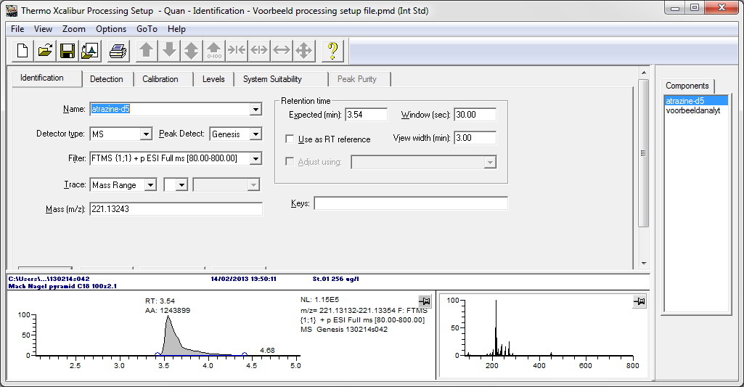
Figure 6.2: Processing Setup - Identification tab
In the Detections tab (Figure 6.3), you can assign the default Peak Integration settings. These default settings are component and sample solvent specific (e.g. MeOH SPE eluent versus direct injection of water samples), and are chosen by visual confirmation of a good peak integration. With a Genesis peak integration algorithm you usually don’t need to change a lot. If the default peak integration isn’t good you can try altering the values here, or try an ICIS peak integration instead of Genesis.
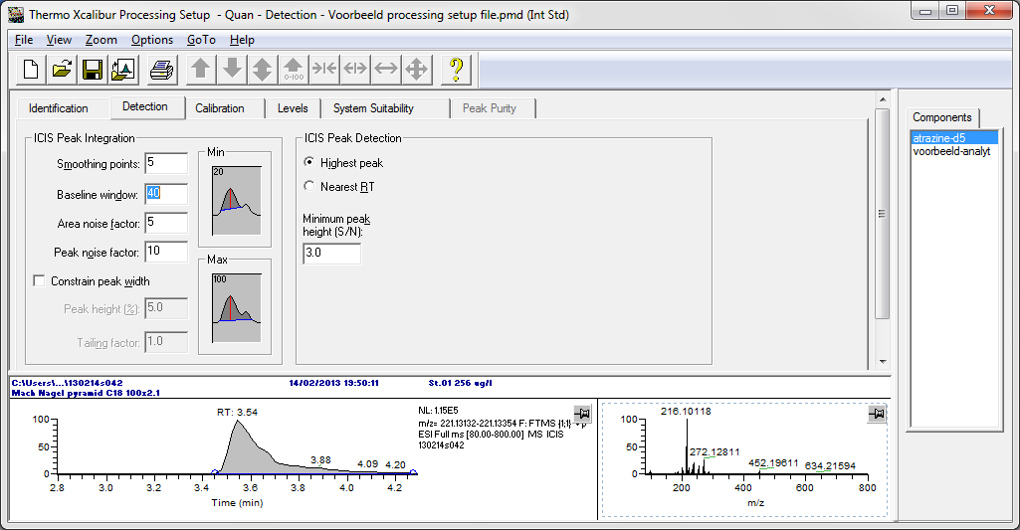
Figure 6.3: Processing Setup - Detection tab
In the Calibration tab (Figure 6.4), indicate that the compound is an internal standard (ISTD), and fill in the concentration in which it was added to the samples and calibration series. The concentration in which the internal standards are added to the samples and calibration curves is given in Table 6.1
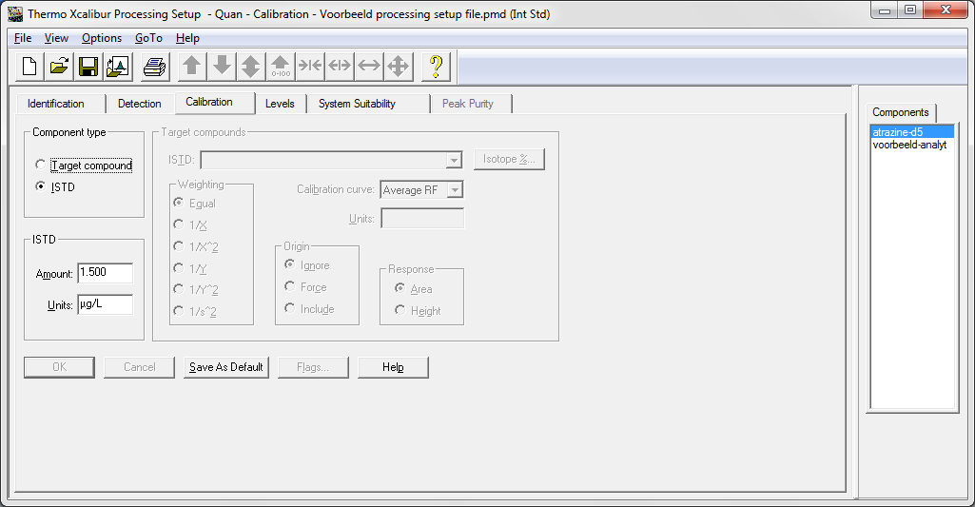
Figure 6.4: Processing Setup - Calibration tab for internal standard
Table 6.1: Internal standards
Compound | Ionisation (+/- ESI) | m/z range | Mass precursor ion dominant isotope | Concentration in injections (µg/L)
Pesticides method
atrazine-d5 | + | 100-700 | 221.13243 | 5
metoprolol-d7 | + | 100-700 | 275.23466 | 75
sulfamethoxazole-13C6 | + | 100-700 | 260.07952 | 30
ketoprofen-d3 | + | 100-700 | 258.12040 | 30
ketoprofen-d3 | - | 100-700 | 256.10585 | 30
diuron-d6 | + | 100-700 | 239.06196 | 15
paracetamol-d4 | + | 100-700 | 156.09571 | 30
ibuprofen-d3 | - | 100-700 | 208.14223 | 30
PF method
ibuprofen-d3 | - | 120-1000 | 208.14223 | 30
metoprolol-d7 | + | 120-1000 | 275.23466 | 75
MPFOS | - | 120-1000 | 502.94574 | 3

Now change the example analyt (voorbeeld-analyt) to an analyt of interest (e.g. atrazine).
Complete the Identification (Figure 6.2) and Detection (Figure 6.3) tabs. In the Calibration tab (Figure 6.5), indicate that the analyt is a Target compound, and select the internal standard corresponding to this analyt. To know which internal standard to use requires some training with data processing. If this is your first time, base yourself purely on retention time (i.e. choose the internal standard which eluted closest to the analyt). You can change the internal standards afterwards once we are processing the analysis data in the Quan Browser. For calibration curves in a long range (usually the case in these measurements), select a weighting of 1/x. Choose linear calibration curves.
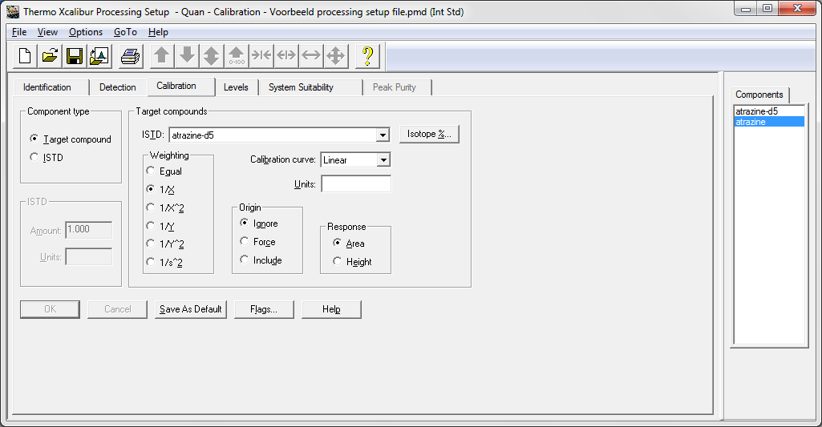
Figure 6.5: Processing Setup - Calibration tab for target compound

In the Levels tab (Figure 6.6), we can fill in the concentrations of the calibration series. It is advised to give level 1 to the lowest concentration, and work your way up from there. The software will display only 3 decimals but will remember the exact concentration.
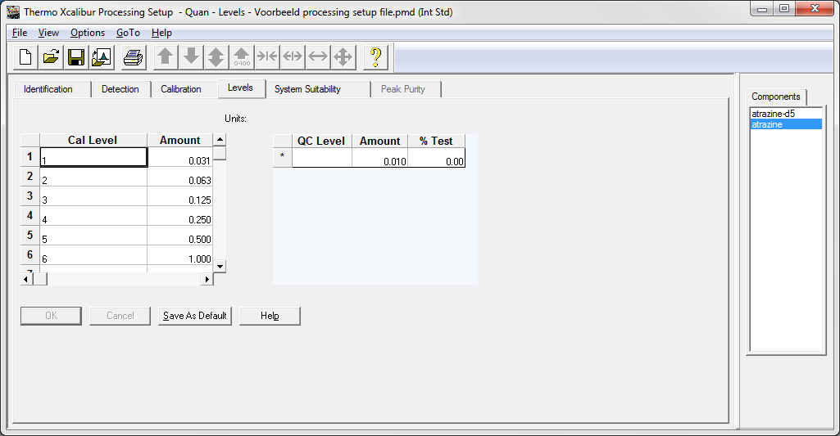
Figure 6.6: Processing Setup - Levels tab
Complete the Processing Setup file by adding all internal standards and analytes which are detected in this method and are present in your samples, and save this Processing Setup file (e.g. Processing Pesticidesmethod 130214).
Hint: You don’t have to type all the levels of the calibration series again, just go to the analyt where you typed them in once, right-click in the levels field, and select Copy Levels To All Target Compounds.

Completing the Sequence List
Now that we have created a Processing Setup file, we need to load this in the sequence list of the injections. Go to the (cleaned up) Sequence List (Xcalibur Roadmap – Sequence Setup), and click the ‘Column Arrangement’ button (Figure 7.1). Make sure that ‘Sample Type’, ‘Level’, and ‘Proc Method’ are being displayed, and move ‘Sample Type’ and ‘Level’ a few places up, while leaving the ‘Proc Method’ column at the bottom.
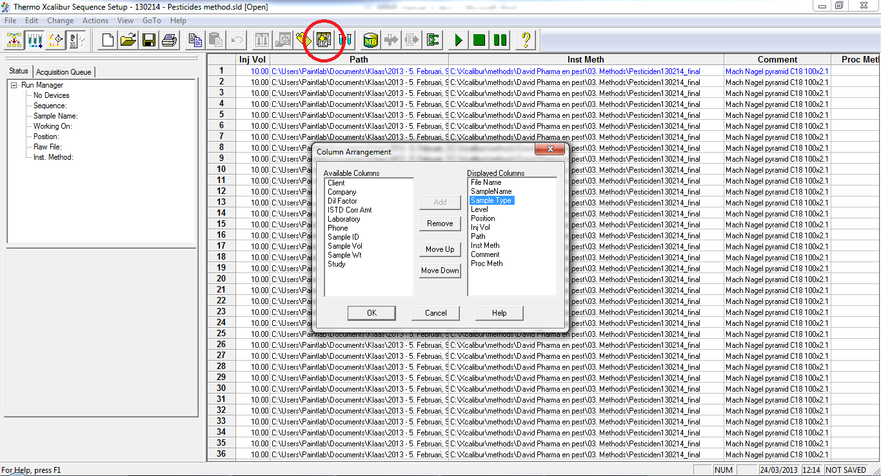
Figure 7.1: Sequence List - Column Arrangement button
Click OK, and scroll to the right (to the Proc Method column), and right-click in the cell of the first injection. Choose Browse, and load the Processing Method File you have created.
Now scroll to the left towards the ‘Sample Type’ and ‘Level’ columns. We need to assign the calibration series to the corresponding injections (Figure 7.2). As Sample type, select ‘Std Bracket’ for the standard injections of the calibration series (Hint: assign the first standard the Std Bracket type, then select the whole calibration serie including the first one, and use the Fill Down button). Then assign the corresponding Level to the correct injection (remember, in the Processing Setup file we assigned level 1 to the lowest standard concentration, which we need to do here as well). Leave the samples as Unknown, as well as the calibration series that has been run at the end of the sample injections.
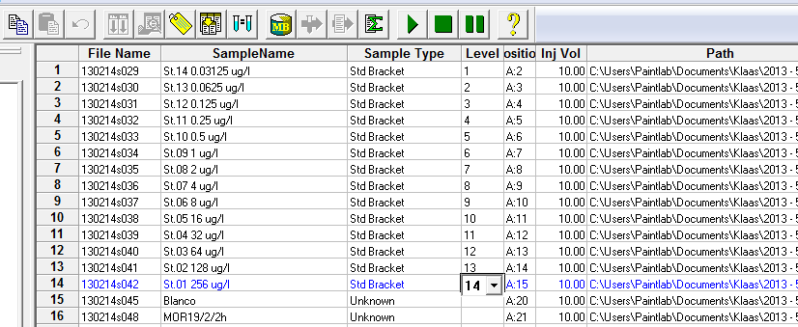
Figure 7.2: Sequence List - Assigning the calibration curve
Save this Sequence List.
Now Select the whole sequence list by clicking the header left of File Name, and above the 1st injection, and click the ‘Batch Reprocess’ button (Figure 7.3).
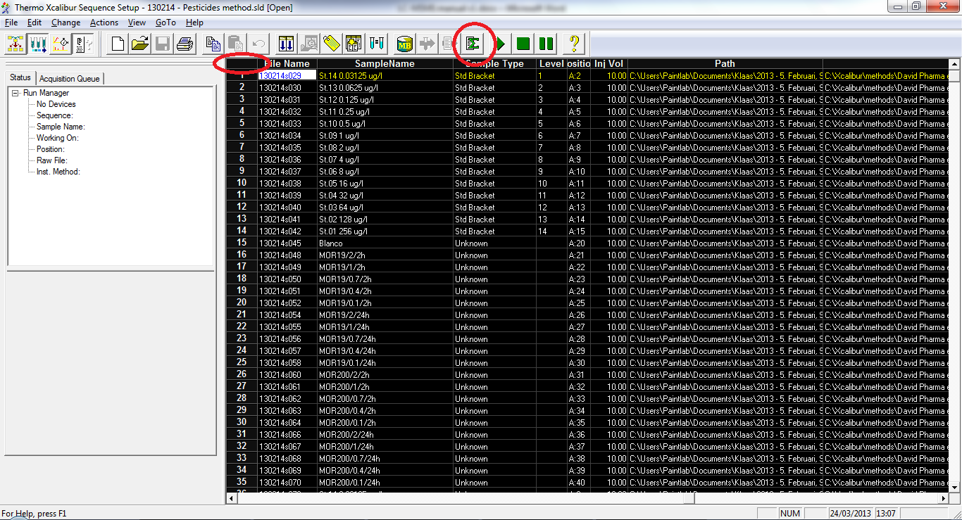
Figure 7.3: Sequence List - Batch Reprocess button
A pop-up appears, but leave the settings as they are (Figure 7.4).
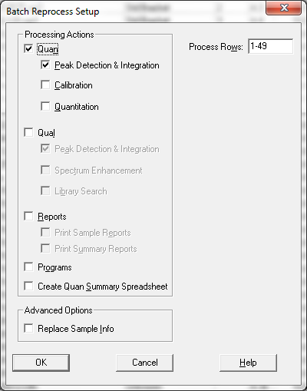
Figure 7.4: Sequence List - Batch Reprocess menu
The software will now use the default settings on all compounds and all injections in the processing setup/sequence list. This may take some time.
After the software has finished, new .rst files will be created in the same folder as the .raw files.
Important: if you have to redo the calculation (e.g. because you assigned another internal standard to an analyt, or if you forgot a compound in your processing method, or if you use the same calibration series for a new set of samples which weren’t processed the first time), you need to move these .rst files to another folder, in order to avoid error messages.

Working with Quan
In the Xcalibur Roadmap, click the Quan Browser button. A new window opens with a popup asking for a sequence list file. Select the completed sequence list file.
When a View Sample Types popup appears, select ‘View All Sample Types’ and click OK. Then the Quan Browser opens with the run from the sequence list (Figure 8.1).
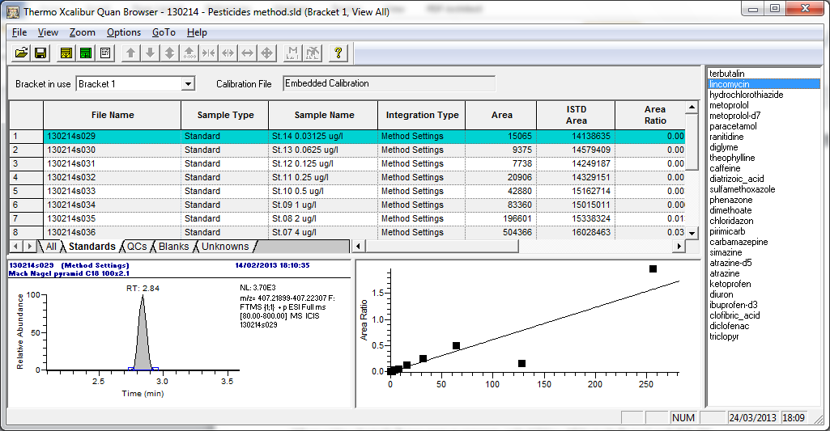
Figure 8.1: Quan Browser - example
The Quan browser provides an overview of all compounds and injections. In the tab Standards, the corresponding injections are displayed and a calibration curve is fitted. You will need to check the peaks, calibration lines, and in some cases m/z spectra. Please read through this whole chapter before starting since every aspect of the Quan Browser is connected to each other.
It is good practice to check the peaks of internal standards first (so select the internal standards in the right column). The peak integrations (see below for how to check peak integrations) are usually OK, but check them to be sure. The m/z spectra are also usually OK. Calibration lines are nonexistent for internal standards since all injections have the same specified amount.
In the above example (Figure 8.1), Lincomycin is displayed. You can see that the 128 µg/L injection is an outlier (actually in this example the volume in the LC vial was too low so almost nothing was injected). You need to exclude this point by right-clicking the point and choosing Exclude. The point turns white, and the software calculates a calibration curve without the excluded point. If you want to include it again, you can right-click it and choose Include.
Go over the peak integrations of the standards, and take a look at the regression curve. Usually it should be linear. If it’s not, try another internal standard, however when changing the calibration curve (e.g. internal standard or curve fitting), always keep an eye on a sample (tab Unknowns or All) with a known concentration (e.g. influent or t=0). If that should be 100 µg/L, then make sure the calculated concentration doesn’t deviate too much from the 100 µg/L. Choosing the wrong internal standard for your analyt can change the outlook of the measurements significantly. In principal you have to compromise between linearity of the calibration curve and the calculated concentration in your known samples. If no useable internal standard results in a linear regression curve, you can try a quadratic one. You can change the type of regression by right-clicking in the regression window, choosing Calibration Settings, and changing the calibration type. Make sure that the peaks are integrated well, you can manually edit the peak integration by clicking on the blue border of the peak, and dragging it to another place in the chromatogram. Keep an eye on the ‘Specified Amount’ and ‘Calculated amount’, as well as the ‘% Diff’ columns. For the standards, these can be useful to know how exactly you must select a peak for a correct peak integration.
Also take a closer look at Areas of the low concentrations of the calibration series. If the peaks are selected correctly but the area is not descending with descending concentration anymore, you need to exclude these points. You can zoom in on the calibration curve by dragging horizontal lines with the mouse pointer. Zooming out can be done by clicking the ‘Reset scaling to full scale’ button.
You can change the used internal standard, the calibration curve type, and the weighting in Quan by right-clicking in the calibration curve window, and choosing ‘Calibration Settings’, on the tabs ‘Type’ and ‘Curve’.
If for an analyt the peaks are poorly integrated, you can choose different default integration settings by right-clicking on the chromatogram peak, and choosing ‘User Peak Detection Settings’. In the tab ‘Identification’ you can choose between Genesis and ICIS, and in the tab ‘Genesis/ICIS Integration’ you can try different values which determine the default integration.
In ‘Working with Quan’, it was already postulated that there are two criteria that need to be met in order to be sure that the peak is indeed the analyt you are looking for: the RT needs to be more or less the same, and the theoretical m/z line distribution spectrum must resemble the m/z line distribution spectrum of the measured peak (i.e. the relative height of the m/z line of the compound with one ¹³C atom to the dominant m/z line of the most abundant isotopes must be approximately the same in the measured spectrum, compared to the theoretical spectrum). This needs to be checked, and is especially important for the lower concentrations. Choose the m/z spectrum to be displayed instead of the calibration plot (View – Set Companion View – Show Spectrum Plot). Zoom in by dragging horizontal lines over the m/z spectrum plot.
In theory, if the m/z spectrum distribution is not corresponding to the theoretical one, the point must be excluded. However it is possible that, for low concentrations the HRMS detector could only detect the dominant m/z line, while the isotope m/z lines were not detected due to all the noise. If the peak area is following the regression line, and the retention time is correct, and you get a peak clearly distinguishable from the noise, you may want to decide to include the point in the calibration curve. The results which were based on this point are only indicative. Results are only reportable if the calibration curve was based on peaks with a consistent RT, correct m/z line distribution, and peaks with a S/N ration higher than 3.

After you have finished checking all the analytes for all standards, you will need to do the same for all the samples.

Exporting to Microsoft Excel
Finally, after you have checked the peaks for all samples, you can export all data to Excel, by clicking File – Export Data to Excel – Export Long Excel report. You can find the concentrations in the column Calculated Amount. These concentrations are in µg/L, providing that you entered the concentrations of the calibration series in µg/L in the Processing Setup – Levels tab.

Finally you can use an Excel macro to automatically reorder the data from each tab into a new Excel workbook. You can find this macro here: http://users.ugent.be/~kschoutt/Excel%20Macro%20-%20XcaliburLongReportNewWorkbookKlaas.txt
In Excel, enable the developers tab (Office button – Excel Options – Popular, and check ‘Show Developer tab in the Ribbon’). Close all Excel files, open only the Excalibur Long Report and click Developers – Visual Basic. In the Microsoft Visual Basic window click Insert – Module, and paste the code into it. Then click the play button. If the macro doesn’t work, you’ll have to change the following on line 22: ‘Set DataWB = Application.Workbooks(1)’ to ‘Set DataWB = Application.Workbooks(2) ’.

