**Shimadzu TOC V-Cpn Analyser 6th floor**

|  |
| --- |
| **COVID RULES:**   1. **First plan and register your analysis day in this** [**Sharepoint Excel**](https://sharepoint.ugent.be/sites/ecochem_laboinfo/_layouts/15/WopiFrame.aspx?sourcedoc=/sites/ecochem_laboinfo/Logfiles/Schedule%20for%20lab%20use%20from%20October.xlsx&action=default)**. If you would not have access to this sheet, please contact** [**Roseline.Blanckaert@UGent.be**](mailto:Roseline.Blanckaert@UGent.be) 2. **If you have no experience with programming the analyzer, please contact Leo, Rishav, Xue, John or Lingshan (backup) for help. Also read this document entirely.** 3. **On the scheduled day of your analysis, visit the analysis lab where the TOC is located only through the direct access door at the end of the hall on your left side.** 4. **If you need to make new calibration curves, bring your own standards and/or make your own stock solution as described underneath.** |

**Things to know:**

* The lab at the 6th floor (Ecochem) opens at 8:00 in the morning, and **CLOSES at 16:00**!

**Start with the analysis early!**

* Use **baked vials of 24 mL**.

*Vials*: VWR cat. nr. 548-0679 (200 PCS). Reusable after proper washing – see below.

*Caps*: Sigma-Aldrich cat. nr. 27056 (100 PCS). Reusable after normal washing.

*Septa (PTFE lined)*: Filter-Service cat. nr. LP 17 02 1415 (100 PCS) Not reusable once pierced.

**Preferably use vials already available in the lab**

* Washing procedure: after using the vials, **wash** them in the dishwasher, afterwards put them in a **0.1 M H3PO4 bath**. Then manually **rinse them thoroughly with milli-Q** water (NOT demi), then package them in aluminium foil and bake them in the oven for **8 hours at 500°C**. Then store them in the cupboard for next use.
* Fill up the vials with milli-Q (NOT demi), standards or samples, and then close them off by wrapping a small piece of **CLEAN aluminium foil** around the top. Alternatively you may also use a screw cap with a septum (which is safer), or you may use a screw cap with aluminium foil in between vial and screw cap, but this is not mandatory. Make sure your hands are *clean* and *dry* when doing this! You can put the vials in the autosampler with the aluminium foil or screw cap + septum or screw cap + aluminium foil still there, no need to remove it.
* You can choose between **NPOC method** or **TC+IC method**. For samples with high concentration in IC, it is often better to measure using the NPOC method, however if your samples contain some purgeable organic carbon you may lose this fraction using the NPOC method. An alternative would be to dilute the samples with milli-Q and use the TC+IC method, however keep in mind you’re introducing uncertainty by diluting with mili-Q (also milli-Q contains around 80 - 110 ppb of organic carbon). In my experience it’s best to stick with the NPOC method for normal surface water samples, however it’s best to review every case on its own, and do a test measurement beforehand.
* TC & IC standards have to be prepared from 1000ppm stock solutions no more than 2 months old.  
    
  **For 500ml of 1000ppm IC stock solution:**-1,75g of NaHCO3 (1S.003)  
  -2,205g of Na2CO3 baked for 1 hour at 285°C(1S.036)  
  -Milli-Q water  
    
    
    
  **For 500ml of 1000ppm TC stock solution:**-1,0625g of C8H5KO4  dried for 2 hours at 120°C (1P.004)  
  -Milli-Q water

A. For the **NPOC** **method**, you will need to prepare standards of TC only. No IC standards are necessary. You must use **FRESH milli-Q (collected from 6th floor)** for making these dilutions! A TC standard of 1000 ppm should be in the fridge in lab 1, in the long narrow bottle.

In total you need to make 5 vials with milli-Q, 3 vials with TC standard of 10 ppm, and 2 vials with TC standard of 100 ppm.

Make the standards like this:



B. For the **TC+IC method**, you will need to prepare standards of TC and IC. You must use **FRESH milli-Q (collected from 6th floor)** for making these dilutions! TC and IC standards of 1000 ppm should be in the fridge in lab 1, in the long narrow bottles.

In total you need to make 5 vials with milli-Q, 3 vials with TC standard of 10 ppm, 2 vials with TC standard of 100 ppm, and 1 vial for each of the IC standards listed below.

Make the standards like this:

* Fill up the vials with samples completely. The machine might use a lot.
* Preferably group your samples in logical series, each series from low to high concentration. If you go from a sample with an expected high concentration to a sample with an expected low concentration, add a flush milli-Q after the one with the high concentration, as no to contaminate the sample with low concentration.

Below, a description is given on how to do an analysis with the NPOC method and as well how to do an analysis with the TC+IC method.

1. **NPOC method**
2. **Turn on** TOC machine (button bottom-right corner), and computer
3. Check if there’s still enough **oxygen gas**! Check the meter on the oxygen gas bottle inside the orange gas cabinet in front of the TOC analyzer
4. BEFORE EVERY analysis run, **2 small white barrels need to be replaced with FRESH milli-Q** water.
   1. There is 1 bottle on the left from the autosampler
   2. There is 1 bottle on the left from the TOC machine
5. On the computer, open program **TOC-Control V**. Click on **Sample Table Editor**. The software asks for a username, but it’s not necessary, just click **OK**.
6. Click **New** and click **OK**.
7. In the bottom left corner of the program there are 5 tabs: 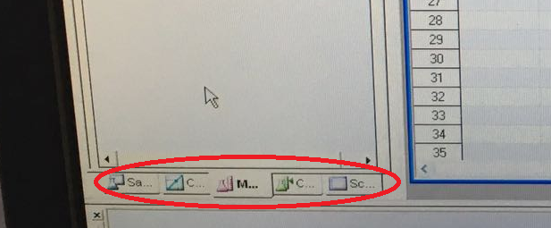

Click on the **Method** tab.

Drag-and-drop **Non-Purgeable Organic Carbon.met** to the right inside the sample table, **TWICE**!

Type ‘**blanc mQ**’ in the Sample Name column for both of these. This way we start our analysis with 2 milli-Q samples, in order to equilibrate the machine a bit right after startup.

1. Go to the **Cal. Curve** tab (In the bottom left corner).

Drag-and-drop **Standard NPOC 1-10 ppm.cal** to the sample table

Drag-and-drop **Standard NPOC 10-100 ppm.cal** to the sample table as well.

This way you add two calibration curves, one in the 1-10 ppm range and one in the 10-100 ppm range. If you add these two, it means that you will be able to measure samples up to 100 ppm NPOC.

1. Go back to the **Method** tab.

Drag-and-drop another **Non-Purgeable Organic Carbon.met** to the sample table, and type ‘**blanc mQ**’ in the Sample Name column for this one. This will be a milli-Q injection to flush the system after measurement of the highest standard of the NPOC calibration.

If everything has been done correctly it should look like this:

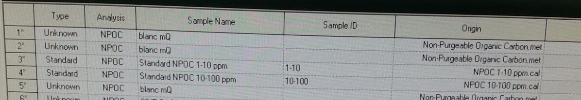

Note that not every line stands for one vial nor injection. The calibrations have multiple injections and vials.

1. Now we will assign the milli-Q’s and standards to the according vial positions in the autosampler. To do this, click the **View Vial Settings** button (it has the symbol of a pie with candles on it ☺).

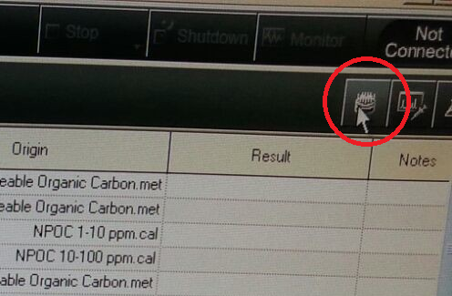

**General rule:** Always make **5 vials with milli-Q** and put them **in the beginning** in the autosampler, that is: 5 vials with milli-Q go in positions 1 to 5.

**General rule:** Every vial can only be **used a maximum of 2 times!** This means you can do a milli-Q injection from the same vial only twice, maximum! Same for vials with standards.

**General rule:** TC standards will be auto-diluted by the machine (only prepare 3 vials containing 10 ppm TC, and 2 vials containing 100 ppm TC).

Assign the **vial positions** (1 to 10 in the Vial column the figure below) to the corresponding injections (milli-Q and TC standards), as in this figure:



In the figure above…

… notice that milli-Q’s are only used 2 times, in accordance to the general rule.

… notice that the NPOC standard of 0,000mg/L is also in fact a milli-Q.

… notice that you need 2 vials containing the 10 ppm TC standard to measure that calibration series, in order to comply to the general rule of using the same vial only twice. The 3rd vial you prepared of 10 ppm TC will be used at the end as a quality control

… notice that you need 2 vials containing the 100 ppm TC standard.

Put the vials with milli-Q and standards in the autosampler tray in the correct positions. That is:

Positions 1 – 5: 5 vials with FRESH milli-Q

Positions 6 – 8: 3 vials with standard 10 ppm TC

Positions 9 – 10: 2 vials with standard 100 ppm TC.

1. Click OK in the Vial Settings window, and go back to the **Method** tab.

Drag-and-drop a few **Non-Purgeable Organic Carbon.met** lines into the sample table. Each of these lines stands for one of your samples you want to measure. Fill in the names of the samples in the **Sample Name** column. Click the **View Vial Settings** button and assign the correct vial tray position numbers to the corresponding sample (this will be from position 11 on). **Do this for all your samples**. Group your samples in a logical sequence.

*Keep in mind that when you go from a sample with an expected high concentration to a sample with an expected low concentration, you should add a flush milli-Q after the sample of a high concentration. If you do this a lot, it is possible that 5 vials with milli-Q won’t be enough, then you need to put more vials with milli-Q in between the samples.*

For every vial you have entered in the Vial Settings window, its position should light up blue in the figure on the right ☺.

1. At the end of all your samples, add 3 more **Non-Purgeable Organic Carbon.met** lines. The first one should be named **milli-Q**, the second one should be named **standard 10 ppm**, the third one should be named **milli-Q**. Basically, this is a quality control. We’re adding one more injection of the 10 ppm standard, in order to check after the measurement if we’re close to this value. If not, then something must have gone wrong during the analysis.

**Assign the tray positions** to this. (milli-Q is vial position 5 on condition that you didn’t use this 5th milli-Q vial in between samples as a flush, the 10 ppm standard is vial position 8 (this is the remaining 10 ppm TC vial we haven’t used during calibration)).

1. Put the tray with vials inside the autosampler, and close it with the lid. The tray should ‘lock’ into position, and the lid must be put in place properly, otherwise the analysis won’t start.

Finally it should look something like this:

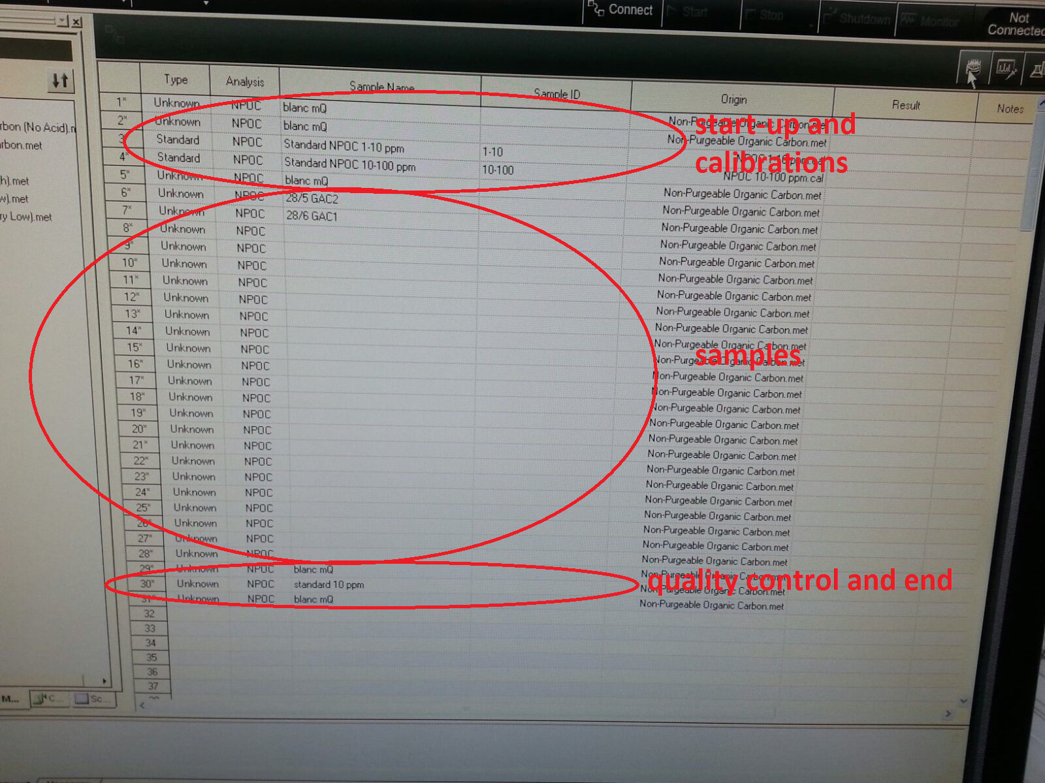

1. **Save** the sample table **in the folder PaInT**. Use the date, followed by your name (**yyyy_mm_dd_name.t32**).

e.g. 2016_06_10_Klaas.t32.

1. Click the **Connect** button.
2. Click the **Start** button.

The machine will ask what to do after it finishes the whole sequence. Choose **Auto Shutdown**.

The analysis should start ☺.

1. **TC+IC method**
2. **Turn on** TOC machine (button bottom-right corner), and computer
3. Check if there’s still enough **oxygen gas**! Check the meter on the oxygen gas bottle inside the orange gas cabinet in front of the TOC analyzer
4. BEFORE EVERY analysis run, **2 small white barrels need to be replaced with FRESH milli-Q** water.
   1. There is 1 bottle on the left from the autosampler
   2. There is 1 bottle on the left from the TOC machine
5. On the computer, open program **TOC-Control V**. Click on **Sample Table Editor**. The software asks for a username, but it’s not necessary, just click **OK**.
6. Click **New** and click **OK**.
7. In the bottom left corner of the program there are 5 tabs: 

Click on the **Method** tab.

Drag-and-drop **Total Organic Carbon (Low).met** to the right inside the sample table, **TWICE**!

Type ‘**blanc mQ**’ in the Sample Name column for both of these. This way we start our analysis with 2 milli-Q samples, in order to equilibrate the machine a bit right after startup.

1. Go to the **Cal. Curve** tab (In the bottom left corner).

Drag-and-drop **TC 1-10 ppm.cal** to the sample table

Drag-and-drop **TC 10-100 ppm.cal** to the sample table as well.

This way you add two calibration curves, one in the 1-10 ppm range and one in the 10-100 ppm range. If you add these two, it means that you will be able to measure samples up to 100 ppm TC.

1. Go back to the **Method** tab.

Drag-and-drop another **Total Organic Carbon (Low).met** to the sample table, and type ‘**blanc mQ**’ in the Sample Name column for this one. This will be a milli-Q injection to flush the system after measurement of the highest standard of the TC calibration.

1. Go to the **Cal. Curve** tab again.

Drag-and-drop **IC 1-10 ppm.cal** to the sample table

Drag-and-drop **IC 10-100 ppm.cal** to the sample table as well.

This way you’ll be able to measure samples up to 100 ppm IC.

1. Go back to the **Method** tab.

Drag-and-drop another **Total Organic Carbon (Low).met** to the sample table, and again type ‘**blanc mQ**’ in the Sample Name column for this one. This will be a milli-Q injection to flush the system after measurement of the highest IC standard of the calibration.

If everything has been done correctly it should look like this:

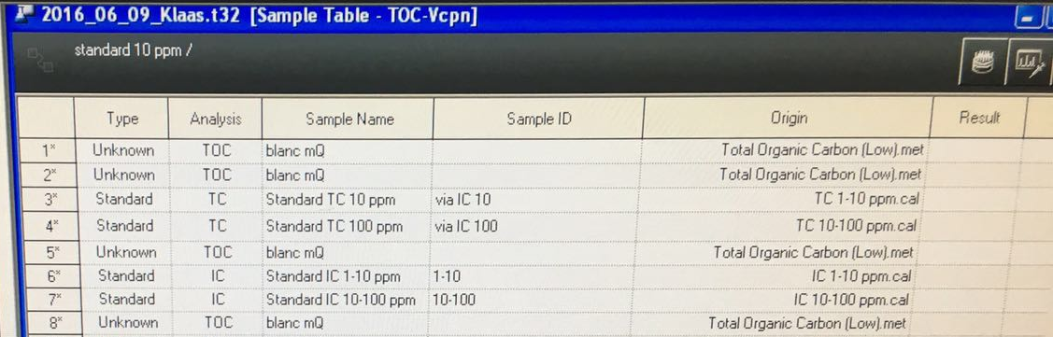

Note that not every line stands for one vial nor injection. The calibrations have multiple injections and vials.

1. Now we will assign the milli-Q’s and standards to the according vial positions in the autosampler. To do this, click the **View Vial Settings** button (it has the symbol of a pie with candles on it ☺).

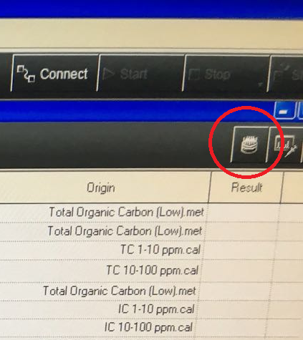

**General rule:** Always make **5 vials with milli-Q** and put them **in the beginning** in the autosampler, that is: 5 vials with milli-Q go in positions 1 to 5.

**General rule:** Every vial can only be **used a maximum of 2 times!** This means you can do a milli-Q injection from the same vial only twice, maximum! Same for vials with standards.

**General rule:** TC standards will be auto-diluted by the machine (only prepare 3 vials containing 10 ppm TC, and 2 vials containing 100 ppm TC. IC standards on the other hand are not auto-diluted by the machine, here you must prepare each IC standard separately.

Assign the **vial positions** (1 to 17 in the Vial column the figure below) to the corresponding injections (milli-Q, TC standards and IC standards), as in this figure:



In the figure above…

… notice that milli-Q’s are only used 2 times, in accordance to the general rule.

… notice that the TC standard of 0,000mg/L is also in fact a milli-Q.

… notice that you need 3 vials containing the 10 ppm TC standard to measure that calibration series, in order to comply to the general rule of using the same vial only twice.

… notice that you need 2 vials containing the 100 ppm TC standard.

… notice that the IC standard of 0,000mg/L is again a milli-Q, from a vial which hasn’t been used before.

… notice that the 10,00mg/L IC standard in the 1-10ppm calibration series can be used again in the 10-100 ppm calibration series.

Put the vials with milli-Q and standards in the autosampler tray in the correct positions. That is:

Positions 1 – 5: 5 vials with FRESH milli-Q

Positions 6 – 8: 3 vials with standard 10 ppm TC

Positions 9 – 10: 2 vials with standard 100 ppm TC

Position 11: standard of 1 ppm IC

Position 12: standard of 2,5 ppm IC

Position 13: standard of 5 ppm IC

Position 14: standard of 10 ppm IC

Position 15: standard of 25 ppm IC

Position 16: standard of 50 ppm IC

Position 17: standard of 100 ppm IC.

1. Click OK in the Vial Settings window, and go back to the **Method** tab.

Drag-and-drop a few **Total Organic Carbon (Low).met** lines into the sample table. Each of these lines stands for one of your samples you want to measure. Fill in the names of the samples in the **Sample Name** column. Click the **View Vial Settings** button and assign the correct vial tray position numbers to the corresponding sample (this will be from position 18 on). **Do this for all your samples**. Group your samples in a logical sequence.

*Keep in mind that when you go from a sample with an expected high concentration to a sample with an expected low concentration, you should add a flush milli-Q after the sample of a high concentration. If you do this a lot, it is possible that 5 vials with milli-Q won’t be enough, then you need to put more vials with milli-Q in between the samples.*

For every vial you have entered in the Vial Settings window, its position should light up blue in the figure on the right ☺.

1. At the end of all your samples, add 3 more **Total Organic Carbon (Low).met** lines. The first one should be named **milli-Q**, the second one should be named **standard 10 ppm**, the third one should be named **milli-Q**. Basically, this is a quality control. We’re adding one more injection of the 10 ppm standard, in order to check after the measurement if we’re close to this value. If not, then something must have gone wrong during the analysis.

**Assign the tray positions** to this. (milli-Q is vial position 5 on condition that you didn’t use this 5th milli-Q vial in between samples as a flush, the 10 ppm standard is vial position 8 (previously during calibration we used this vial only once so you can choose this one here again)).

1. Put the tray with vials inside the autosampler, and close it with the lid. The tray should ‘lock’ into position, and the lid must be put in place properly, otherwise the analysis won’t start.

Finally it should look something like this:

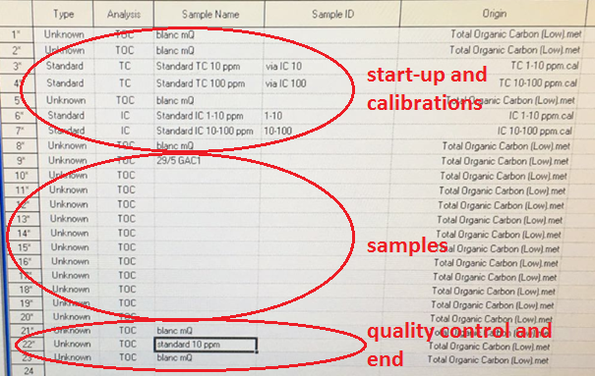

1. **Save** the sample table **in the folder PaInT**. Use the date, followed by your name (**yyyy_mm_dd_name.t32**).

e.g. 2016_06_09_Klaas.t32.

1. Click the **Connect** button.
2. Click the **Start** button.

The machine will ask what to do after it finishes the whole sequence. Choose **Auto Shutdown**.

The analysis should start ☺.