ATTACHMENT A: enrol for a group on a course site.

- Go to the course site of the course concerned: click on ‘groups’ in the blue toolbar.

- Click on the blue button: ‘view available groups’
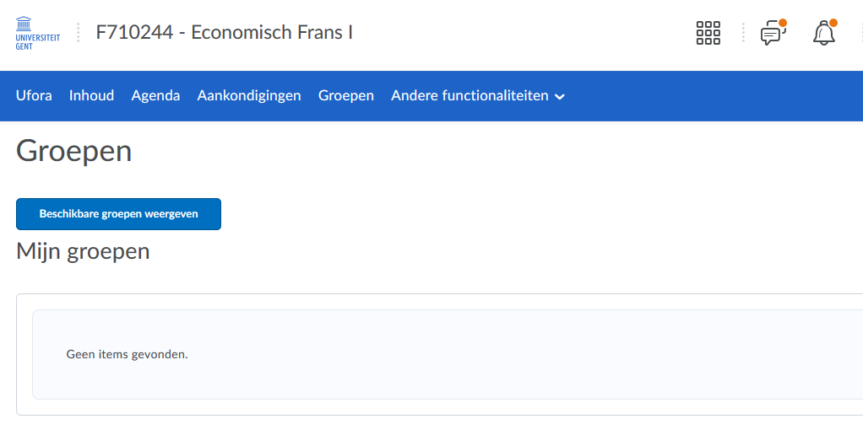
- Choose which class you want to follow by clicking ‘join group’.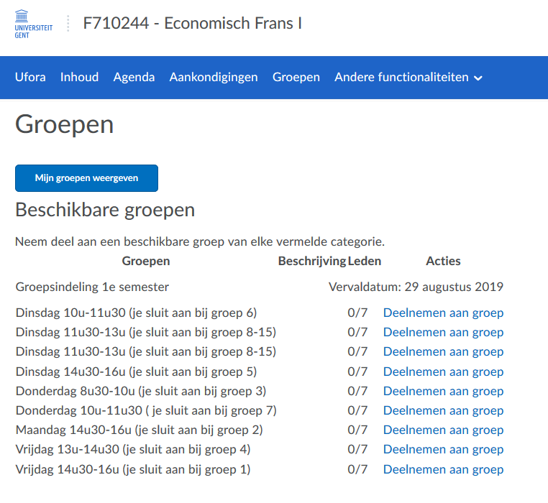
6. You are now enrolled for this group. Via Ufora you can find an overview of all your groups.
You will see this screen automatically after you finished step 5.
