ATTACTHMENT B: composing your curriculum in Centauro
Go to www.Centauro.UGent.be and in the bottom left click on the button ‘schedule configuration’.
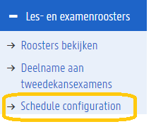
On this page you can choose which group you wish to see for each course in your calendar. Fill in your group number for each course and then click on ‘my calendar’ in the left menu. After that, your time table with the correct group for each course will be shown.
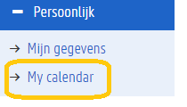

You can watch, print or export this calendar. Click on ‘export’. Before you do this, make sure to reset all the old data by clinking ‘reset private iCalendar address’.
Afterwards, you can copy your iCalendar to your own electronic calendar. In order to export the calendar you open your own electronic calendar, click on adding calendar from URL and paste the link.
