Biobased Innovation Student Competition Europe
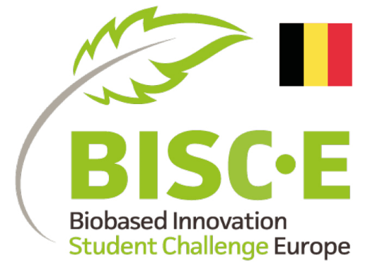
Regulations 2023 Contents
- AIM 1
- ORGANISATION 1
- INDICATIVE TIMELINE – Belgium 1
- PARTICIPANTS 2
- REGISTRATION 2
- CHALLENGE 2
- JURY AND ASSESSMENT 3
- AWARD 4
- EUROPEAN FINALS 4
- INTELLECTUAL PROPERTY 4
- GENERAL 4

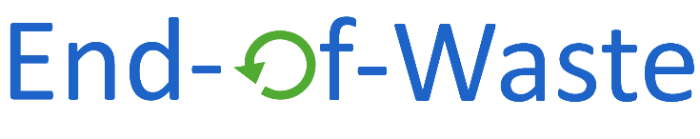

Contact details of BISC-E coordinator : Nathan De Geyter ; nathan.degeyter@ugent.be ; +32 (0) 476476453

Aim
  - The Bio-based Innovation Student Competition Europe (BISC-E) aims to raise awareness and involve students in the transition towards a bio-based economy. The ability to work in a multidisciplinary team is believed to be essential to design viable bio-based solutions, therefore the requirements include technical, environmental and economic elaborations.

Organisation
  - The Bio-based Innovation Student Competition Europe is organized on a national level by the UGent GREEN-CHEM and End-of-Waste networks. After the national finals, a European final is organized where all national winners can compete for the title of European Champion.

Indicative timeline – Belgium
03 March 2023 Fun registration event to brainstorm ideas, to meet previous winners and other participants and create teams (exact location in Ghent to be decided)
17 March 2023 Application deadline for recorded presentation and participation file
28 March 2023 Belgian final and ranking of top 3 teams (at Vlaanderen Circulair event in Leuven)
Autumn 2023 EU final (location to be decided by Biobased Industry Consortium)

Participants
  - Teams of 3 to 8 students Ma/Ba are welcome to join the challenge. However, it is advised to limit the number of team members to 6.
  - All team members should be enrolled in a programme at a Belgian education institution, either in the final year of a Bachelor's degree at a university of applied sciences (technical college) or in a Bachelor or Masters programme at a university at the moment of registration.
  - The innovations proposed by the teams are judged on technical, environmental and economic criteria. With an eye on the multidisciplinary character of the competition, it is highly advised, though not obliged, to embody students with different study backgrounds in your team. Mixed teams with students from both universities of applied sciences and universities or different institutions are encouraged.
  - Each team must appoint one student as team manager. The team manager coordinates the contact between the competition organisers and the other team members.
  - Each team should be supported by one main supervisor employed at one of the host institutions as e.g. lector, PhD candidate, assistant professor, associate professor or professor. More staff members can be asked for support or advice of course but these hold no official role in the competition.
  - Students and supervisors can only join one team participating in the challenge.
  - At least 2 team members should be present for the digital preselection and the finals.

Registration
  - The registration for BISC-E can be done by sending your form and presentation to endofwaste@ugent.be
  - For registration for the Belgian challenge you need:
    - A team name
    - Team manager (one of the student team members)
    - A supervisor (as stated under 4.5)
    - To fill in the participation form
    - Personal details of the team members
    - A slide deck to be presented in the finals (see 6.1, 6.7)
  - The teams are checked to ensure they comply with the regulations as stated in this document. In case the team or a team member is not eligible for this challenge, the team manager will be notified within 2 weeks after closing of the registrations.

Challenge
  - In this challenge, student teams are asked to develop a bio-based product or bio-based process that could be integrated in the current (or near future) economy.
  - The followed definition of bio-based product is: A product composed in whole, or for a significant part, of biological material derived from renewable biological sources, including plant, animal or marine materials. Where product is defined as: substance, mixture of substances, material or object resulting from a production process, this can be an intermediate, material, semi-finished or final product.
  - The followed definition for bio-based process is: A process using only, or for a significant part, bio-based feedstock. Bio-based as defined above. The process may yield intermediate products or energy or have another economic value.
  - The innovation may, but does not have to, replace a fossil derived product / fossil based process.
  - The use of agricultural wastes or residues, food and feed (by-)products as well as other biowastes as resource for bio-based products is included in the challenge. The development of a new food or feed product and their production process is excluded from this challenge.
  - Individual work, done in the framework of a MSc-thesis, is not eligible for this challenge. Further development in a team is eligible as long it is a clear team effort.
  - The challenge consists of an oral presentation with supporting information, addressing the elements mentioned in 6.8.
  - Two tracks can be followed.
- For innovations concerning a bio-based product.

- For innovations leading to a bio-based process or bio-based improvements of a process step. Also services or other innovations strongly advancing the bio-based economy (not leading to a touchable prototype product that can be presented) fall in this category.
  - The teams will provide the presentation and supporting documents on the registration deadline. In the case that there are more than 3 teams that register, a first selection will be held on the basis of the presentation and supporting documents that have been submitted during the registration according to the selection criteria (as described in 7.4 except the subcriterium on presentation skills). The supporting documents consist of a description of the process or product (½ A4), a description of the technical aspects (½ A4) and the outline of the business case (½A4). The claims in the business case and / or production process should be supported with basic calculations (additional).
The 15’ presentation for the Belgian Final will comprise the following elements:

    - Short description of the innovation

    - Introduction and explanation of the innovative aspect (including illustrations)

    - Technical explanation of the innovation, e.g.
      - Production process of a product or process scheme of a process
      - Mass balances
      - The bio-based materials used
      - (Production)process energy use estimation

    - Elaboration of the positive environmental impact of the innovation, e,g
      - product life cycle / process resource chain
      - input, output and residual streams
      - comparison with conventional product or process (if applicable)

    - Economic viability, e.g.
      - Business model canvas with explanation
      - SWOT analysis
      - Quantitative and qualitative market analysis and a cost benefit analysis

  - For the Belgian Finals with the top three candidates a complete dossier has to be submitted per group. This dossier consists of all supporting documents and the final presentation. The jury will review these dossiers before the final. Limited appendices (e.g. References, additional figures, table) are allowed but are not part of the evaluated material.
  - All text and spoken words have to be in English.
  - Each of the top 3 teams will have the chance to present their bio-based innovation and prototype product / process animation to the jury during the actual final. The oral presentation, supported by slides, lasts 15 minutes followed by the possibility for the jury to ask questions during 5 minutes.
  - The presentation and the submitted dossier – in case of the European Finals - should contain only work of the team members or properly referenced work of others.

Jury and assessment
  - The jury will consist of a number of experts in the field of bio-based economy / process technology / agriculture / environmental impact assessment, from academia or industry.
  - Jury members cannot be involved in any way with any of the participating teams.
  - The jury members will not be announced before the submission deadline.
  - The presentation, including the Q&A session, during the preselection is considered by the jury. The innovations are evaluated by the jury on the following points:
- Innovation: How creative and novel is the concept? Does it solve an existing problem or does it replace a petroleum-based product?
- Sustainability impact: First of all, is the innovation truly bio-based. Is it also environmentally friendly, i.e. does it have a better environmental performance / more environmentally friendly production process compared to the product it replaces or does it enhance the sustainability of a process throughout the total life cycle? And how big is the positive impact for the environment if the product or process would be widely applied.
- Technical feasibility: In case of a product, the technical feasibility of the proposed production process is considered. In case of a process / process innovation the feasibility of the claimed advantages are considered.
- Economic viability: Is there a market for the proposed product? Is there economic incentive to apply the proposed product or process innovation? Economic viability of the product or process.
- Presentation and prototype product / process animation: The presentation is judged on content and presentation skills together with the quality of the answers offered to the jury's questions. Also the appearance and professionality of the prototype product / process animation is considered under this point.
  - No detailed communication about the jury's decisions is possible.

Award
  - The monetary award is provided 'as is' (any taxation should be paid by the receiving party) and is divided equally over the team members. The first team will receive 1000€ + coaching and free tickets and travel to the EU finals, the second 500€ and the third 250€.
  - In case the winning team rejects the price or does in any way not comply with these regulations the organization has the right to select another winner.

European finals
  - The aim is to have multiple European countries organizing a national competition similar to the Belgian competition. The winning teams of all national competitions will present their innovations to win the European award. At the moment of start of the Belgian competition it is still unclear how many other countries will organize a national competition.
  - The team winning the first prize in the Belgian competition can go to the European final.
  - Reasonable travel expenses, accommodation costs and entrance to the event are reimbursed to a maximum of € 1500 per team and a maximum of € 500 per team member.
  - In case the winning team rejects the offer to join the European final, the organization has the right to let another team represent the country at the European finals.

Intellectual property
  - Only the jury and the organization has access to the presentation and submitted dossier – in case of the European Final - and personal information for matters related to the competition only.
  - All IP and know-how in the submitted materials of teams remain the property of the original owners, submission will not result in any transfer of ownership to the organizers, jury and sponsors of the competition. Foreground IP and know-how generated by the students during the competition rests with the students and can be protected or published in close consultation with the supervisor at the host institution.

General
  - All deadlines mentioned with a date only are before 23:59 CET that day.
  - The organization may always make exemptions to these regulations without notice or providing the reason.
  - The organization can exclude a participant or a team when not complying to these regulations, acting against the law or otherwise acting immoral.
  - The BISC-E organization team reserves the right to amend, postpone or cancel the competition or to change the dates and conditions without incurring liability if circumstances beyond its control require to do so.
  - All participants permit the organization, free of charge, to use personal information and team information including information on the designed innovation and awarded prices for promotional purposes. Also pictures and other contributions provided in the context of the challenge can be used free of charge for promotion via different media channels.
  - In all situations not foreseen in this regulations or in case of a dispute the organization shall decide how to resolve the problem.

