Dante Workshop
(UGent, 13-14 May 2019)

Location: UGent, Campus Boekentoren (Blandijnberg 2, 9000 – Ghent, Belgium)

Free entrance

Organizers: prof. Teodoro Katinis (UGent; SDA Gent), prof. Wim Verbaal (UGent), prof. Bart van den Bossche (KU Leuven), prof. Andrea Robiglio (KU Leuven).

Research groups: GEMS (Group for Early Modern Studies), HPIMS (Henri Pirenne Institute for Medieval Studies).

Participants: prof. Paolo Borsa (University of Milan), prof. Valerio Cappozzo (University of Mississipi), prof. Teodoro Katinis (UGent, SDA Gent), prof. Wim Verbaal (UGent), prof. Bart van den Bossche (KU Leuven), prof. Andrea Robiglio (KU Leuven), colleagues of the GEMS and the HPIMS, PhD students, students of the course LKV.

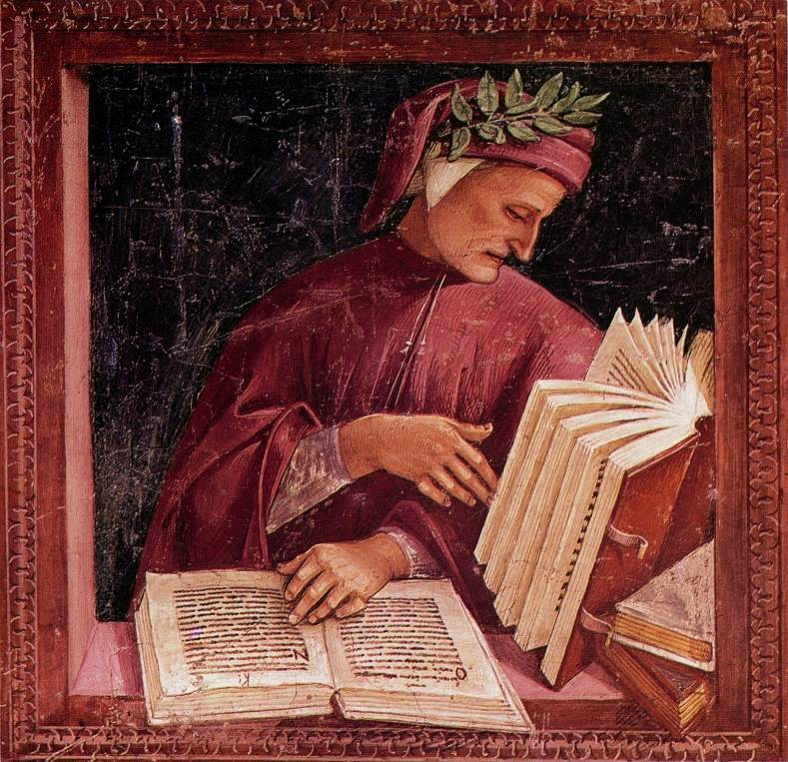
Program

13/5: Room 120.036

h15-17: Dante Alighieri between Latin and the Vernacular, in English.
Moderators: Wim Verbaal and Andrea Robiglio.
Prof. Paolo Borsa and prof. Valerio Cappozzo will circulate in advance their materials to feed the discussion: published articles and current projects with specific regards to Dante’s poetry, the Stilnovo, and the interpretation of dreams in the Middle Ages.

h17: coffee break and networking.

h18:30: dinner.

h20-22: prof. Valerio Cappozzo, L’interpretazione dei sogni da Dante ad oggi, in Italian for the Società Dante Alighieri – Gent (for a broad public).

14/5: Room 120.012

Morning: informal meetings with PhD students and colleagues to discuss future research opportunities (feel free to contact us if you are interested in meeting the speakers).

h16-19: Dante tra latino e volgare, in Italian.
Moderator: Teodoro Katinis.
Prof. Paolo Borsa e prof. Valerio Cappozzo, for the students of LKV. Articles and handouts will circulate in advance. External participants are welcome to join also this part of the workshop.

h20: dinner

[Image reference: Luca Signorelli, Portrait of Dante (1500-1504 ca.). Fresco. Orvieto Cathedral, Chapel of St Britius.]

