ATTACHMENT C: enrol for a group on an info site
1. Log in on Ufora (ufora.ugent.be).
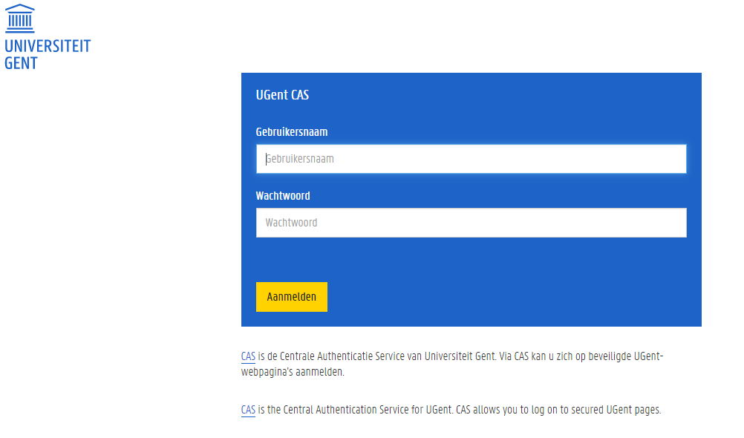

2. Click on the infosite which is relevant for your programme:

- ‘Bachelor of Science in de Economische Wetenschappen’
- ‘Bachelor of Science in de Toegepaste Economische Wetenschappen’ óf
- ‘Bachelor of Science Handelsingenieur’

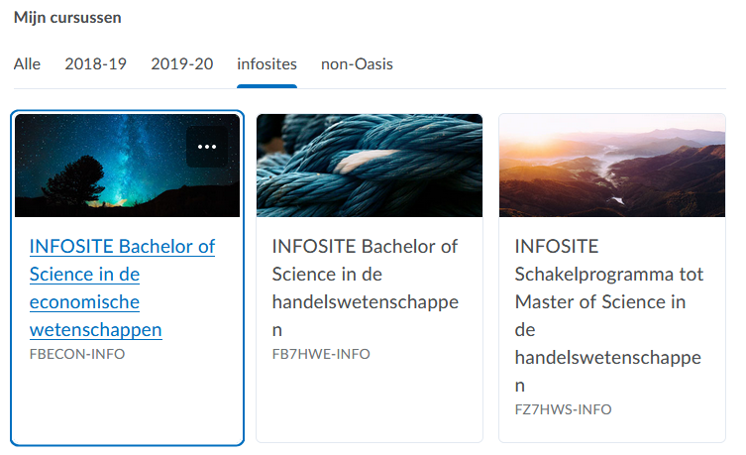

3. Go to ‘groups’ in the blue toolbar.


4. Click on the blue button: ‘view available groups’
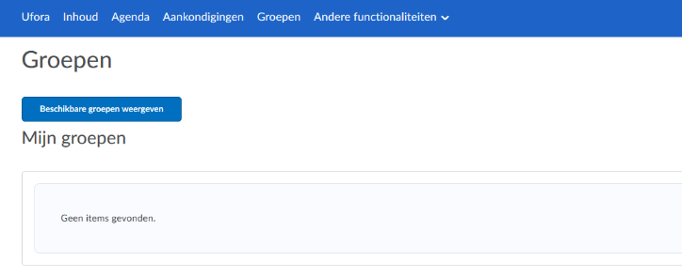

5. Choose which class you want to follow by clicking ‘join group’ on the right side of the group.
Example:
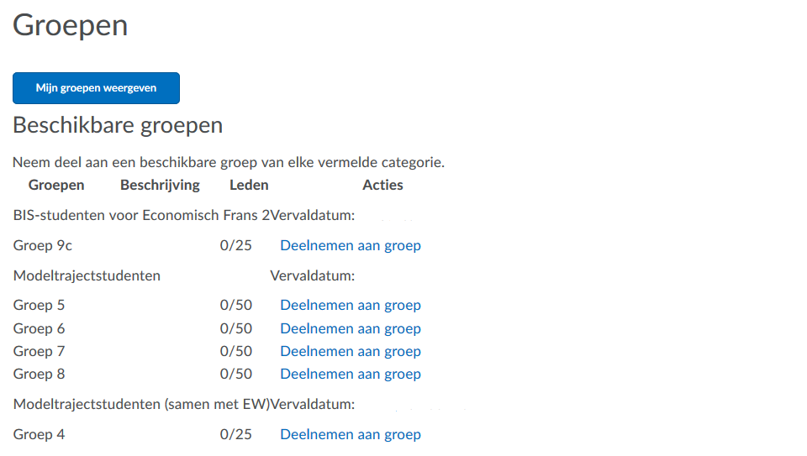

6. You are now enrolled for this group. Via Ufora you can find an overview of all your groups.
You will see this screen automatically after you finished step 5.
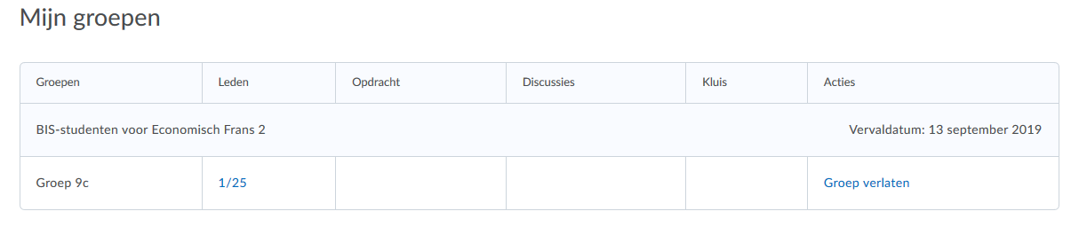

You can find more information about exercises (start date, preparation,…) via Ufora on the course site of the course concerned.
You have to follow the classes according to your group assignment in the class schedule.

As soon as you are enrolled for academic year 2020-2021, you will see all the infosites that are relevant for you at the bottom of the homepage of Ufora. If you do not see these infosites, you can enrol for them. On http://ufora.ugent.be in the top left corner you click on the arrow next to ‘Ufora’ and select ‘enrol for course’ in the dropdown menu. Fill in (a part of) the name in the search field. The name of the course will appear and you can enrol by clicking on the infosite concerned.

