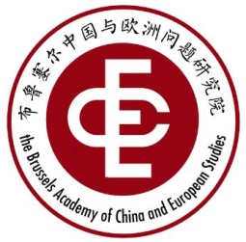 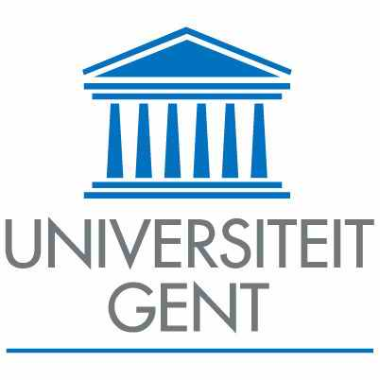  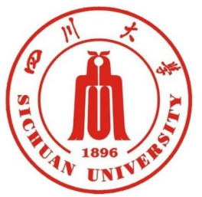

**"EU - China relations: actual conditions and future perspectives"**

**Ghent Workshop**

Het Pand, Onderbergen 1, Ghent

Room: Oude Infirmerie

July 6-7, 2017

|  |  |  |
| --- | --- | --- |
| July 5, Wed. | Short pre-meeting and dinner | |
| **July 6,**  **Thursday** | **09:30-10:00** | Arrival & registration |
| **10:00 - 10:30** | Opening speech by **Guido Van Huylenbroeck** (UGent), Academic Director for Internationalisation  Group Photo |
| **10:30 – 11:00** | Coffee break |
| **11:00 – 12:30**  3 SPEAKERS, 20 min. MAX./PP | **Session 1**: "The Sustainability of China-EU Relations in the Changing World" - I  Chair：**Jian SHI** (SCU & BACES)  1. **Jan ORBIE** (UGent & BACES**)**  2. **SONG Xinning** (RUC & BACES) “China - EU Relationship”  3. **WEI Liang** (China Institute of Contemporary International Relations) "Belt & Road Initiative: opportunity for China-European cooperation"  Q&A |
| **13:00 - 14:00** | Lunch @ Het Pand |
| **14:30 - 16:30**  4 SPEAKERS, 20 min MAX./PP | **Session 2:** "The Sustainability of China-EU Relations in the Changing World" - II  Chair:  **Fabienne Bossuyt** (UGent)  4. **Daojiong CHA** (Beijing University) “Energy dimension of EU-China relations”  5. **Sven Biscop** (UGent & BACES) “EU-China-US-Russia relationship"  6. **Duncan Freeman** (College of Europe) “Global or Bilateral Priorities: Climate and Economic Dimensions in the EU-China Relationship”  7. **ZHUANG Yan**（CUST & SCU), “New Synergy of EU-China Cultural  Cooperation under the Framework of ‘Belt and Road’ Initiative”  Q&A |
| **17:30 - 18:30** | Boat tour |
| **19:00 – 21:00** | Welcome dinner @ Multatuli |

|  |  |  |
| --- | --- | --- |
| **July 7,**  **Friday** | 08:30-09:00 | Registration |
| **09:00-10:30**  3SPEAKERS,  20 min. MAX./PP | **Session 2**: Results of the Survey on “European Integration: Realities and Challenges – Perspectives from Chinese Youth"  Chair: **Bart Dessein** (UGent & BACES)  1. **Zhuyu LI (**SCU & BACES**)**: "EU's visibility and Impressions in Chinese College Students: Description of the Survey"  2. **Jian SHI (**SCU & BACES**)**: "To Promote the Dialogue between the Youth of China and EU"  3. **H. Hennig-Schmidt (**Bonn University）：“European University Students’ Perception of EU-China Relationship with a Comparison to Chinese Students”  Q&A |
| **10:30 -11:00** | Coffee break |
| **11:00-12:00**  2 SPEAKERS,  20 min. MAX./PP | 4. **Dan YI (**SCU & BACES**)**: "Understanding the Channels of China-EU Youth Mutual Cognition：Macro Information through Micro Permeating""  5. **Zeren LANGJIA** (UGent & SCU**)**: "China-EU Relations in the Eyes of Chinese College Students"  Q&A |
| **12:00-12:30** | Closing ceremony |
| **13:00-14:00** | Lunch @ Parnassus |