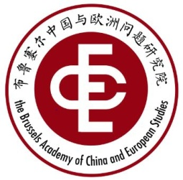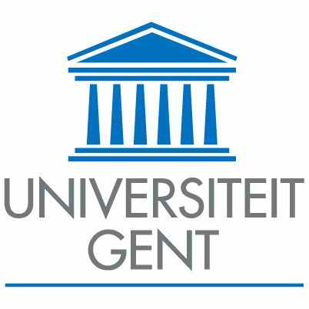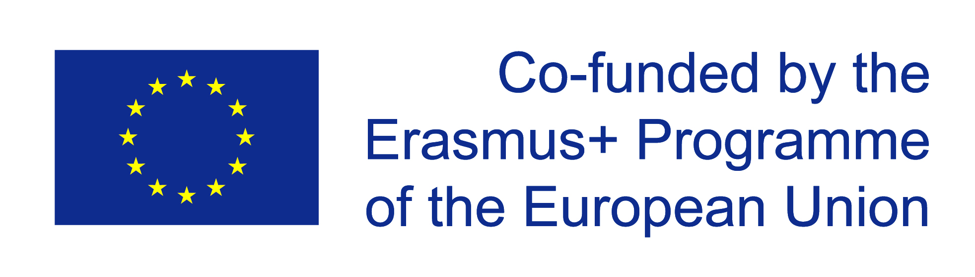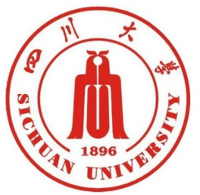
"EU - China relations: actual conditions and future perspectives"
Ghent Workshop
Het Pand, Onderbergen 1, Ghent
Room: Oude Infirmerie
July 6-7, 2017
July 5, Wed. | Short pre-meeting and dinner
July 6,  Thursday | 09:30-10:00 | Arrival & registration
July 6,  Thursday | 10:00 - 10:30 | Opening speech by Guido Van Huylenbroeck (UGent), Academic Director for Internationalisation  Group Photo
July 6,  Thursday | 10:30 – 11:00 | Coffee break
July 6,  Thursday | 11:00 – 12:30  3 SPEAKERS, 20 min. MAX./PP | Session 1: "The Sustainability of China-EU Relations in the Changing World" - I  Chair：Jian SHI (SCU & BACES)  1. Jan ORBIE (UGent & BACES)  2. SONG Xinning (RUC & BACES) “China - EU Relationship”  3. WEI Liang (China Institute of Contemporary International Relations) "Belt & Road Initiative: opportunity for China-European cooperation"  Q&A
July 6,  Thursday | 13:00 - 14:00 | Lunch @ Het Pand
July 6,  Thursday | 14:30 - 16:30  4 SPEAKERS, 20 min MAX./PP | Session 2: "The Sustainability of China-EU Relations in the Changing World" - II  Chair: Fabienne Bossuyt (UGent)  4. Daojiong CHA (Beijing University) “Energy dimension of EU-China relations”  5. Sven Biscop (UGent & BACES) “EU-China-US-Russia relationship"  6. Duncan Freeman (College of Europe) “Global or Bilateral Priorities: Climate and Economic Dimensions in the EU-China Relationship”  7. ZHUANG Yan（CUST & SCU), “New Synergy of EU-China Cultural  Cooperation under the Framework of ‘Belt and Road’ Initiative”  Q&A
July 6,  Thursday | 17:30 - 18:30 | Boat tour
July 6,  Thursday | 19:00 – 21:00 | Welcome dinner @ Multatuli

July 7,  Friday | 08:30-09:00 | Registration
July 7,  Friday | 09:00-10:30  3SPEAKERS,  20 min. MAX./PP | Session 2: Results of the Survey on “European Integration: Realities and Challenges – Perspectives from Chinese Youth"  Chair: Bart Dessein (UGent & BACES)  1. Zhuyu LI (SCU & BACES): "EU's visibility and Impressions in Chinese College Students: Description of the Survey"  2. Jian SHI (SCU & BACES): "To Promote the Dialogue between the Youth of China and EU"  3. H. Hennig-Schmidt (Bonn University）：“European University Students’ Perception of EU-China Relationship with a Comparison to Chinese Students”  Q&A
July 7,  Friday | 10:30 -11:00 | Coffee break
July 7,  Friday | 11:00-12:00  2 SPEAKERS,  20 min. MAX./PP | 4. Dan YI (SCU & BACES): "Understanding the Channels of China-EU Youth Mutual Cognition：Macro Information through Micro Permeating""  5. Zeren LANGJIA (UGent & SCU): "China-EU Relations in the Eyes of Chinese College Students"  Q&A
July 7,  Friday | 12:00-12:30 | Closing ceremony
July 7,  Friday | 13:00-14:00 | Lunch @ Parnassus

